

**MINISTRY OF EDUCATION AND TRAINING**

**INTERIOR QUOTATION SYSTEM**

SOFTWARE REQUIREMENT SPECIFICATION

|  | |
| --- | --- |
| Project Code | NJS1706 |
| Document Code | NJS1706-G4- v1.0 |
| Group Member | Chu Công Danh - SE172215  Trần Tuấn Kiệt - SE173673  Hồ Dương Gia Phú - QE170201  Trần Lâm Khánh - SE170063  Lê Minh Khoi - SE172757 |
| Supervisor | Mr. Tran Thanh Nguyen |

Ho Chi Minh , March 2024

TABLE OF CONTENT

[**1. INTRODUCTION 4**](https://docs.google.com/document/d/1TS5wvkcf1_9zPMUJ0hffIPhNxMxSzw7_9Jiy9vOwqj8/edit?fbclid=IwAR25-_W1A44psZxh5_1O9qYI5Ktn2F38GivWSITmp-Rl_qfViAWBxKmKhWg#heading=h.vmx4oxhtfhh)

[1.1. Purpose 4](https://docs.google.com/document/d/1TS5wvkcf1_9zPMUJ0hffIPhNxMxSzw7_9Jiy9vOwqj8/edit?fbclid=IwAR25-_W1A44psZxh5_1O9qYI5Ktn2F38GivWSITmp-Rl_qfViAWBxKmKhWg#heading=h.dxambv483tls)

[1.2. Scope 4](https://docs.google.com/document/d/1TS5wvkcf1_9zPMUJ0hffIPhNxMxSzw7_9Jiy9vOwqj8/edit?fbclid=IwAR25-_W1A44psZxh5_1O9qYI5Ktn2F38GivWSITmp-Rl_qfViAWBxKmKhWg#heading=h.b5xlvgk64fsq)

[1.3. Definitions, Acronyms, and Abbreviations 4](https://docs.google.com/document/d/1TS5wvkcf1_9zPMUJ0hffIPhNxMxSzw7_9Jiy9vOwqj8/edit?fbclid=IwAR25-_W1A44psZxh5_1O9qYI5Ktn2F38GivWSITmp-Rl_qfViAWBxKmKhWg#heading=h.7kek2pasadfp)

[1.4. References 5](https://docs.google.com/document/d/1TS5wvkcf1_9zPMUJ0hffIPhNxMxSzw7_9Jiy9vOwqj8/edit?fbclid=IwAR25-_W1A44psZxh5_1O9qYI5Ktn2F38GivWSITmp-Rl_qfViAWBxKmKhWg#heading=h.xm1r331rm0nf)

[1.5. Overview 5](https://docs.google.com/document/d/1TS5wvkcf1_9zPMUJ0hffIPhNxMxSzw7_9Jiy9vOwqj8/edit?fbclid=IwAR25-_W1A44psZxh5_1O9qYI5Ktn2F38GivWSITmp-Rl_qfViAWBxKmKhWg#heading=h.bba261uhzhha)

[**2. OVERALL DESCRIPTION 6**](https://docs.google.com/document/d/1TS5wvkcf1_9zPMUJ0hffIPhNxMxSzw7_9Jiy9vOwqj8/edit?fbclid=IwAR25-_W1A44psZxh5_1O9qYI5Ktn2F38GivWSITmp-Rl_qfViAWBxKmKhWg#heading=h.gen6tzk6k7hd)

[2.1 . Product perspective 6](https://docs.google.com/document/d/1TS5wvkcf1_9zPMUJ0hffIPhNxMxSzw7_9Jiy9vOwqj8/edit?fbclid=IwAR25-_W1A44psZxh5_1O9qYI5Ktn2F38GivWSITmp-Rl_qfViAWBxKmKhWg#heading=h.5it4v37eq8fh)

[2.2. Product function 7](https://docs.google.com/document/d/1TS5wvkcf1_9zPMUJ0hffIPhNxMxSzw7_9Jiy9vOwqj8/edit?fbclid=IwAR25-_W1A44psZxh5_1O9qYI5Ktn2F38GivWSITmp-Rl_qfViAWBxKmKhWg#heading=h.7j02pfbo98ou)

[2.3. User characteristic 7](https://docs.google.com/document/d/1TS5wvkcf1_9zPMUJ0hffIPhNxMxSzw7_9Jiy9vOwqj8/edit?fbclid=IwAR25-_W1A44psZxh5_1O9qYI5Ktn2F38GivWSITmp-Rl_qfViAWBxKmKhWg#heading=h.6ih5p0xvnv17)

[2.4. Constraints 8](https://docs.google.com/document/d/1TS5wvkcf1_9zPMUJ0hffIPhNxMxSzw7_9Jiy9vOwqj8/edit?fbclid=IwAR25-_W1A44psZxh5_1O9qYI5Ktn2F38GivWSITmp-Rl_qfViAWBxKmKhWg#heading=h.azslwiks1tzk)

[2.5. Assumptions and dependencies 9](https://docs.google.com/document/d/1TS5wvkcf1_9zPMUJ0hffIPhNxMxSzw7_9Jiy9vOwqj8/edit?fbclid=IwAR25-_W1A44psZxh5_1O9qYI5Ktn2F38GivWSITmp-Rl_qfViAWBxKmKhWg#heading=h.kmkc0hepdo9b)

[2.6. Requirements subsets 11](https://docs.google.com/document/d/1TS5wvkcf1_9zPMUJ0hffIPhNxMxSzw7_9Jiy9vOwqj8/edit?fbclid=IwAR25-_W1A44psZxh5_1O9qYI5Ktn2F38GivWSITmp-Rl_qfViAWBxKmKhWg#heading=h.krfb9i2scho5)

[**3. FUNCTIONAL REQUIREMENTS 13**](https://docs.google.com/document/d/1TS5wvkcf1_9zPMUJ0hffIPhNxMxSzw7_9Jiy9vOwqj8/edit?fbclid=IwAR25-_W1A44psZxh5_1O9qYI5Ktn2F38GivWSITmp-Rl_qfViAWBxKmKhWg#heading=h.tpk6mhg070q7)

[3.1. Use Case Diagram 13](https://docs.google.com/document/d/1TS5wvkcf1_9zPMUJ0hffIPhNxMxSzw7_9Jiy9vOwqj8/edit?fbclid=IwAR25-_W1A44psZxh5_1O9qYI5Ktn2F38GivWSITmp-Rl_qfViAWBxKmKhWg#heading=h.rffue8mds9bn)

[3.2. Use Case Lists 13](https://docs.google.com/document/d/1TS5wvkcf1_9zPMUJ0hffIPhNxMxSzw7_9Jiy9vOwqj8/edit?fbclid=IwAR25-_W1A44psZxh5_1O9qYI5Ktn2F38GivWSITmp-Rl_qfViAWBxKmKhWg#heading=h.gqoej7oyhcug)

[3.3 Use Case Detail](https://docs.google.com/document/d/1TS5wvkcf1_9zPMUJ0hffIPhNxMxSzw7_9Jiy9vOwqj8/edit?fbclid=IwAR25-_W1A44psZxh5_1O9qYI5Ktn2F38GivWSITmp-Rl_qfViAWBxKmKhWg#heading=h.ocei7uxl8qcv)  [14](https://docs.google.com/document/d/1TS5wvkcf1_9zPMUJ0hffIPhNxMxSzw7_9Jiy9vOwqj8/edit?fbclid=IwAR25-_W1A44psZxh5_1O9qYI5Ktn2F38GivWSITmp-Rl_qfViAWBxKmKhWg#heading=h.l5wqp5d8ugf7)

[**4. NON - FUNCTIONAL REQUIREMENTS 134**](https://docs.google.com/document/d/1TS5wvkcf1_9zPMUJ0hffIPhNxMxSzw7_9Jiy9vOwqj8/edit?fbclid=IwAR25-_W1A44psZxh5_1O9qYI5Ktn2F38GivWSITmp-Rl_qfViAWBxKmKhWg#heading=h.muqrimr93hi)

[4.1. Usability 134](https://docs.google.com/document/d/1TS5wvkcf1_9zPMUJ0hffIPhNxMxSzw7_9Jiy9vOwqj8/edit?fbclid=IwAR25-_W1A44psZxh5_1O9qYI5Ktn2F38GivWSITmp-Rl_qfViAWBxKmKhWg#heading=h.soqjurxf131u)

[4.2. Reliability 134](https://docs.google.com/document/d/1TS5wvkcf1_9zPMUJ0hffIPhNxMxSzw7_9Jiy9vOwqj8/edit?fbclid=IwAR25-_W1A44psZxh5_1O9qYI5Ktn2F38GivWSITmp-Rl_qfViAWBxKmKhWg#heading=h.6vvrh5is4dd0)

[4.3. Performance 135](https://docs.google.com/document/d/1TS5wvkcf1_9zPMUJ0hffIPhNxMxSzw7_9Jiy9vOwqj8/edit?fbclid=IwAR25-_W1A44psZxh5_1O9qYI5Ktn2F38GivWSITmp-Rl_qfViAWBxKmKhWg#heading=h.b1o4kvsb7vh9)

[**5. SUPPORTING INFORMATION 135**](https://docs.google.com/document/d/1TS5wvkcf1_9zPMUJ0hffIPhNxMxSzw7_9Jiy9vOwqj8/edit?fbclid=IwAR25-_W1A44psZxh5_1O9qYI5Ktn2F38GivWSITmp-Rl_qfViAWBxKmKhWg#heading=h.pegczl40hicz)

# **1. INTRODUCTION**

## **1.1. Purpose**

This document serves as the Software Requirements Specification (SRS) for the **Interior Construction Quotation System**. Its aim is to delineate the scope, both functional and non-functional software requirements, along with design constraints of the entire logic sub-component and other pertinent factors essential for a comprehensive understanding of the software's requirements. Additionally, it elucidates the detailed design of the system's interfaces.

## **1.2. Scope**

**The Interior Construction Quotation System** is a small-scale application developed, designed to aid in generating quotations for interior construction projects.

The system offers a suite of features and subsystems enabling users to create quotations for their interior construction projects. Specifically, it allows users to input necessary information and generate quotations for their projects. They can track the progress of their quotations and make adjustments as needed. Emphasising user convenience, the system provides a smooth and secure experience for individuals involved in generating quotations for interior construction projects.

## **1.3. Definitions, Acronyms, and Abbreviations**

| **Acronym** | **Definitions** | **Abbreviations** |
| --- | --- | --- |
| Guest | A person using the system without logging |  |
| Customer | System users can log in to view quotes |  |
| Staff | A person using the system as distributor to manage the operating of Quotes request and product |  |
| Admin | A person using the system as a distributor . The purpose is to manage organise accounts |  |

## **1.4. References**

| **Refer template** |  |
| --- | --- |
| **Refer use case details** |  |
| **Refer non-functional requirement** |  |

## **1.5. Overview**

1. **The next chapter** is the OVER DESCRIPTION section of this document provides an overview of the product's functionality. It describes the informal requirements and is used to establish the context for the specification in the next chapter.

2. **The third chapter** ,the Functional Requirements section of this document specifying the specific actions or operations that a software system should perform containing use cases and detailed description .

3. **The fourth chapter** , the Non-functional Requirements section, of this document is written to define the qualities or constraints that a software system should possess.

4. **The last chapter** , the Supporting information section , of this document provides the supporting information that makes the SRS easier to use. It includes:

* Table of contents
* Index
* Appendices and be considered part of the requirements or not.

# **2. OVERALL DESCRIPTION**

## **2.1 .Product perspective**

The Interior Construction Quotation System is a standalone software application designed to assist contractors in creating quotations and managing interior construction projects. It provides a comprehensive set of tools and resources to support contractors in developing effective project proposals and improving the behaviour and performance of interior construction projects' owners. The system is intended to be used as a supplemental tool alongside traditional project management techniques.

The system will be deployed as a web-based application, and all users will access it through the website using the internet. The website will serve as the main user interface where users can perform all the provided functionalities. The system is expected to be an effective tool to support users in creating quotations for interior construction projects and to enhance their knowledge and skills in interior construction.

## **2.2. Product function**

The system application can run on any operating system with a web browser and internet support, allowing users to access the website using various devices such as computers, iPads, and smartphones. Users can easily register, log in, and create quotations for projects or for themselves through simple steps. Additionally, they can track the progress of their quotations effectively with this system. The system also provides a wealth of blogs for users to view and enrich their knowledge about the world of interior construction.

The system also provides a lot of blogs for users can view and enrich their knowledge about bird world

## **2.3. User characteristic**

| **User** | **Description** |
| --- | --- |
| Guest | A person using the system without logging |
| Customer | A person using the system with logging to view quotes |
| Staff | A person using the system as distributor to manage the operating of Quotes request and product |
| Admin | A person using the system as a distributor . The purpose is to manage organise accounts |

All user need to login to the system for easy management but guest can see detail order without login

Characteristics:

1. There is only 1 admin account in the system
2. The Account of customer is in charge of the staff
3. All guest and customer can register and login to become member of this system because these account do not require any special characteristics of user

## **2.4. Constraints**

The Interior Construction Quotation System is subject to the following constraints:

Technology Constraints: The system must be developed using web-based technologies to ensure compatibility across different platforms and devices. The chosen technologies should support the required functionality and provide a user-friendly interface.

Compatibility Constraints: The system should be compatible with popular web browsers such as Chrome, Firefox, and Safari. It should also be compatible with different operating systems including Windows, macOS, and Linux.

Security Constraints: The system must implement appropriate security measures to protect user information and ensure data confidentiality. This includes encryption of sensitive data, secure user authentication and authorization mechanisms, and protection against common security vulnerabilities.

Performance Constraints: The system should be designed to handle a large number of users simultaneously without significant performance degradation. Response times for user interactions should be fast to provide a seamless user experience.

Accessibility Constraints: The system should adhere to accessibility guidelines to ensure that it can be used by individuals with disabilities. This includes providing alternative text for images, keyboard navigation support, and compatibility with screen readers.

Scalability Constraints: The system should be designed to accommodate future growth and scalability requirements. It should be able to handle an increasing number of users, quotations, and construction projects without significant architectural changes.

Time and Budget Constraints: The development of the Interior Construction Quotation System should be completed within a specified timeframe and budget. The project should be managed efficiently to meet the given constraints and deliver the required functionality.

Usability Constraints: The system should be intuitive and user-friendly, with clear navigation and well-designed interfaces. The user interactions should be straightforward and require minimal training for users to understand and operate the system effectively.

Localization Constraints: The system should support multiple languages and provide localization features to cater to users from different regions and cultural backgrounds. This includes the ability to display content in different languages and handle local date and time formats.

These constraints need to be considered throughout the design and development process of the Interior Construction Quotation System to ensure that the final product meets the specified requirements and provides a satisfactory user experience.

## **2.5. Assumptions and dependencies**

**Assumptions:**

Internet Connectivity: It is assumed that users of the Interior Construction Quotation System will have a stable internet connection to access the system and its features. The system heavily relies on internet connectivity for user interactions, quotation creation, progress tracking, and accessing resources.

User Devices: It is assumed that users will have access to devices such as computers, laptops, smartphones, or tablets with web browsers to access the Interior Construction Quotation System. The system should be compatible with a variety of devices and screen sizes to provide a seamless user experience.

User Account Registration: It is assumed that users will be required to register an account with the Interior Construction Quotation System in order to access personalised features such as quotation creation, progress tracking, and accessing user-specific information. The registration process may involve providing personal information and agreeing to terms and conditions.

Payment Processing: It is assumed that the system will support online payment processing for service fees related to quotation creation or other features. Users will be required to provide payment information and complete the necessary steps to make payments securely.

**Dependencies:**

Third-Party APIs and Services: The Interior Construction Quotation System may have dependencies on third-party APIs or services for functionality such as payment processing, authentication and authorization, and content management. These dependencies need to be integrated and properly configured within the system.

Database Management System: The system may rely on a database management system to store and retrieve user information, quotation data, project details, and other relevant data. The selection and configuration of the database management system will be a dependency for the system's overall functionality.

Security Frameworks and Libraries: The system may depend on security frameworks and libraries to implement secure authentication, data encryption, and protection against common security vulnerabilities. These dependencies need to be integrated and configured appropriately to ensure the security of user data and system integrity.

Development Tools and Frameworks: The development of the Interior Construction Quotation System may require the use of specific programming languages, frameworks, and development tools. The availability and compatibility of these tools will be a dependency for the development team.

Content Creation and Management: The system's effectiveness depends on the availability of high-quality content related to interior construction, project management, and quotation creation. The system may have dependencies on content creators, administrators, and contributors to develop and manage the content effectively.

## **2.6 Requirements subsets**

The requirements for the Interior Construction Quotation System can be categorised into the following subsets:

**User Management Requirements:**

* The system should provide user registration and login functionality.
* Users should be able to create and manage their profiles.
* The system should support different user roles, such as contractors, clients, administrators, and guests, with appropriate permissions and access levels.

**Quotation Management Requirements:**

* Users should be able to create, edit, and manage quotations for interior construction projects.
* The system should support customization of quotations with project details, materials, labour costs, and additional fees.
* Users should be able to generate and download quotation documents in various formats such as PDF or Excel.

**Project Management Requirements:**

* The system should allow users to manage and track the progress of interior construction projects.
* Users should be able to assign tasks, set deadlines, and monitor project milestones.
* The system should provide collaboration tools for team communication, file sharing, and project documentation.

**Communication and Notification Requirements:**

* The system should support communication channels between contractors, clients, and project stakeholders.
* Users should receive notifications and updates regarding project status, quotation approvals, and upcoming deadlines.
* The system should provide messaging, email alerts, and in-app notifications for effective communication.

**Reporting and Analytics Requirements:**

* The system should generate reports and analytics related to quotations, project progress, and financial performance.
* Users should be able to view key metrics, charts, and graphs to assess project profitability and efficiency.
* The system should support data visualisation and filtering options for customised reporting.

**Integration and Customization Requirements:**

* The system should integrate with third-party tools and services for payment processing, document management, and customer relationship management.
* Users should be able to customise system settings, templates, and workflows to meet their specific business needs.
* The system should provide APIs and developer tools for integration with external systems and custom feature development.
* These requirements subsets provide a comprehensive overview of the functionalities and features required for the successful implementation of the Interior Construction Quotation System. Each subset addresses specific aspects of user interaction, system management, and project execution to ensure an efficient and effective solution for contractors and clients in the interior construction industry.

## **2.7 Management Approach**

Applying the Scrum model to the management process gives the Furniture Quotation System project team a powerful coordination tool, necessary for quick and flexible implementation in the context of extremely tight project completion times limited period.

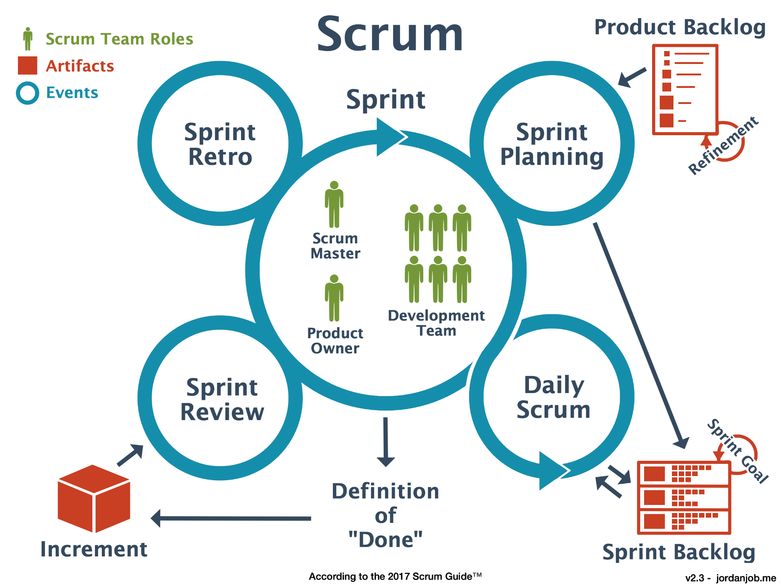

## **2.8 Project Process**

Our team has adopted the Scrum model – a component of the Agile methodology – for project management for the following reasons:

* Given the limited experience of team members, the adoption of Scrum optimises the learning and skill development process through structured and guided teamwork.
* This model encourages in-depth discussions about project content, significantly improving communication and team working efficiency.
* Scrum allows the project to be divided into smaller segments, making it easier to monitor, implement, and make adjustments if there are any misdirections.
* Prioritising tasks and automating repetitive work fosters an environment conducive to continuous innovation and improvement.

Thêm bảng ghi tên 5 thành viên vào đi

## **2.9 Tools & Infrastructures**

| **UML tools** | Draw.io |
| --- | --- |
| **Version Control** | GitHub |
| **Project management tool** | Google Drive |
| **Framework** | ReactJS, |
| **Programming languages** | Javascript, C# |
| **DBMS** | DBeaver |
| **API** | RESTful API |
| **Deployment server** |  |
| **IDEs/ Updaters** | Visual Studio Code, Intellij |

# **3. FUNCTIONAL REQUIREMENTS**

## 3.1. Use Case Diagram

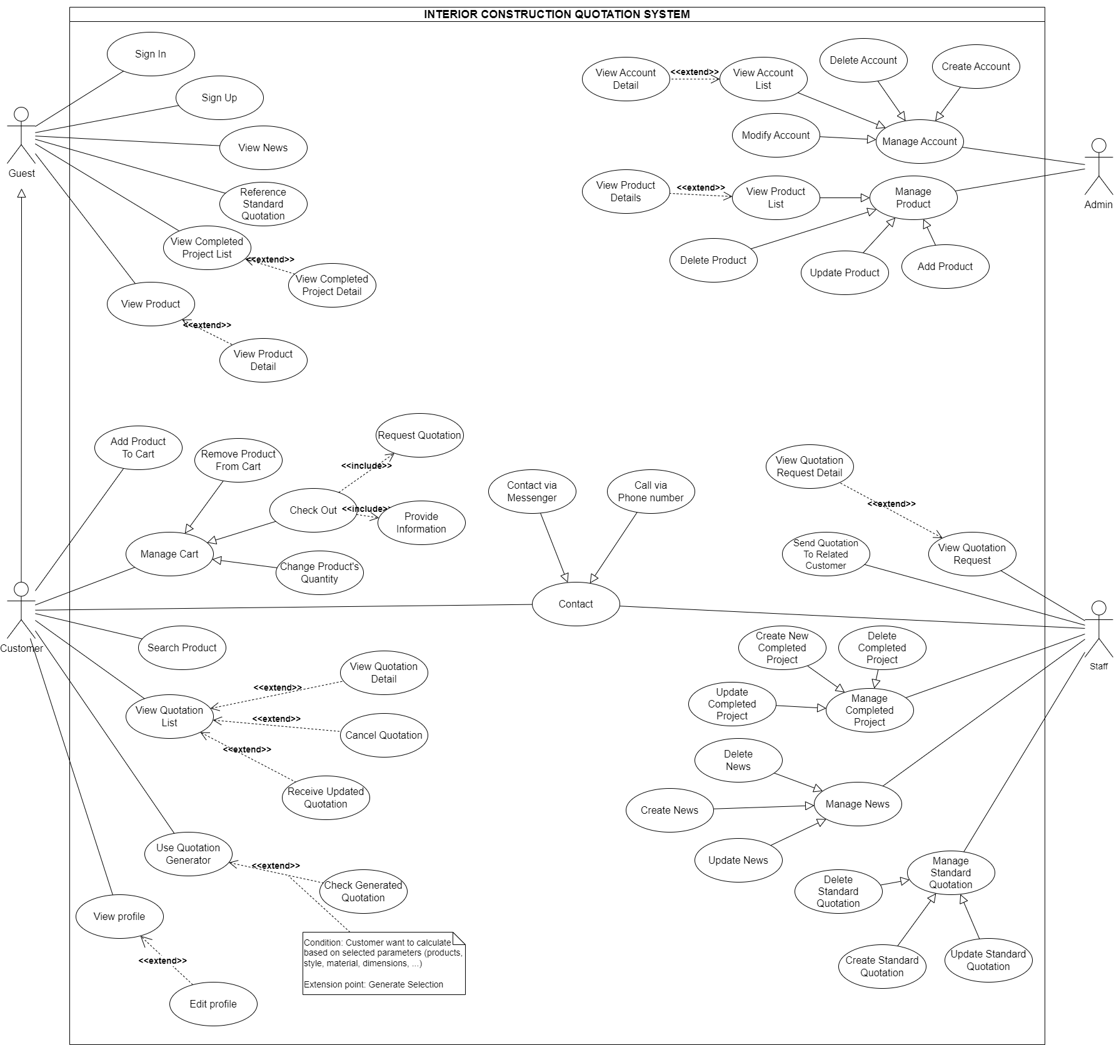

## 3.2. Use Case Lists

| **ID** | **Use Case** | **Actor** |
| --- | --- | --- |
| UC - -01 | Sign in | Guest, Customer , Staff , Admin |
| UC - 02 | SIgn up | Guest |
| UC - 03 | View News | Guest |
| UC - 04 | Reference Standard Quotation | Guest |
| UC - 05 | View Completed Project List | Guest |
| UC - 06 | View Completed Project Detail | Guest |
| UC - 07 | View Product | Guest |
| UC - 08 | View Product Details | Guest |
| UC - 09 | Search Product | Guest |
| UC - 10 | View Quotation List | Customer |
| UC - 11 | Cancel Quotation | Customer |
| UC - 12 | View Quotation Detail | Customer |
| UC - 13 | Receive Contract Based On Submitted Quotation | Customer |
| UC - 14 | View Contract Detail | Customer |
| UC - 15 | Confirm Contract | Customer |
| UC - 16 | Create Quotation | Customer |
| UC - 17 | Manage Cart | Customer |
| UC - 18 | Add Product To Cart | Customer |
| UC - 19 | Change Product's Quantity | Customer |
| UC - 20 | Remove Product From Cart | Customer |
| UC - 21 | Check Out | Customer |
| UC - 22 | Submit Quotation | Customer |
| UC-23 | Select parameters | Customer |
| UC-24 | View profile | Customer |
| UC-25 | Edit profile | Customer |
| UC-26 | Manage Account | Admin |
| UC-27 | Create Account | Admin |
| UC-28 | Delete Account | Admin |
| UC-29 | View Account List | Admin |
| UC-30 | View Account Detail | Admin |
| UC-31 | Modify Account | Admin |
| UC-32 | Manage Product | Admin |
| UC-33 | Add Product | Admin |
| UC-34 | Update Product | Admin |
| UC-35 | Delete Product | Admin |
| UC-36 | View Product List | Admin |
| UC-37 | View Product Details | Admin |
| UC-38 | View Quotation Request | Staff |
| UC-39 | View Quotation Request Detail | Staff |
| UC-40 | Accept Customer's Quotation | Staff |
| UC-41 | Send Contract To Related Customer | Staff |
| UC-42 | Manage Completed Project | Staff |
| UC-43 | Create New Completed Project | Staff |
| UC-44 | Update Completed Project | Staff |
| UC-45 | Delete Completed Project | Staff |
| UC-46 | Manage News | Staff |
| UC-47 | Create News | Staff |
| UC-48 | Update News | Staff |
| UC-49 | Delete News | Staff |
| UC-50 | Manage Standard Quotation | Staff |
| UC-51 | Create Standard Quotation | Staff |
| UC-52 | Update Standard Quotation | Staff |
| UC-53 | Create Standard Quotation | Staff |

## 

## 

## **3.3 Business Rules**

| **ID** | **Rule Definition** | **General Business** |
| --- | --- | --- |
| BR–01 | Users must register and login with a unique username and password. | **User Management** |
| BR–02 | Password complexity requirements may be enforced (e.g., minimum length, character types). |
| BR–03 | Users can update their profiles with personal information. |
| BR–04 | Account management may involve functionalities like viewing account details, modifying settings, or deleting accounts (subject to specific rules). |
| BR–05 | Access controls might restrict who can create, update, and delete content (e.g., news articles, standard quotations) | **Content Management** |
| BR–06 | Content may require approval workflows before publishing. |
| BR–07 | Specific content formats or guidelines might be defined to ensure consistency and quality. |
| BR–08 | Product information should be accurate and up-to-date. | **Product Management** |
| BR–09 | Product listings might require approval before publishing. |
| BR–10 | Inventory management might be integrated if the system allows product purchases. |
| BR–11 | Reference quotations might be based on historical data or industry standards. | **Quotation Management** |
| BR–12 | User-generated quotations might require following a specific format with standard sections. |
| BR–13 | Quotation submission might trigger workflows for review and approval. |
| BR–14 | Contract generation and management might follow defined procedures. |
| BR–15 | Access controls might restrict who can view or manage project details. | **Project Management** |
| BR–16 | Completed projects might require specific information or documentation. |
| BR–17 | Project creation, update, and deletion might follow approval workflows. |
| BR–18 | Products added to the quotation should be reflected accurately. | **Shopping Cart Management** |
| BR–19 | Stock availability might be considered during cart management. |
| BR–20 | Checkout might involve functionalities like payment processing and order confirmation. |

## **3.4 Use Case Detail**

### **UC- 01: Sign In**

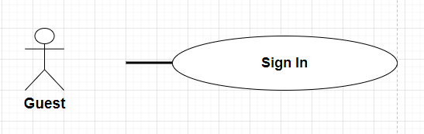

| **UC-01 SIGN IN** | | | |
| --- | --- | --- | --- |
| Use-Case No: | UC01 | Use-Case Version: | 1.0 |
| Use-Case Name: | Sign in | Date Created | 18/03/2024 |
| Author: | KietTT | | |
| Actor: | Guest | | |
| Priority: | High | Frequency of Use: | High |
| Summary: | The User wants to log in this system to meet her/his need. | | |
| Goal: | Allow users with valid credentials to access the system based on their role. | | |
| Triggers: | This function allows users who have a specific username and password to login to this system to do their role. | | |
| Pre-conditions: | User must have a registered account with a username and password.  Alternatively, the user can have a registered Facebook, Google account, or phone number. | | |
| Post-conditions: | User is logged into the system with appropriate access based on their role.  Login session is recorded in a log file.  User sees the home screen. | | |
| Normal Flow: | | Step | Actor Action | System Response | | --- | --- | --- | | 1 | User click “Login” button in the navigation bar | The system will display a form screen with the following fields:   * Username * Password * [ Login ] Button * [ Reset ] Button to delete all user input * [ Remember Me ] Button to save the cookie of user login . | | 2 | User input valid username and password , then clicks on the Login button or hits Enter . | The system checks the existing account in the database and takes user to the page corresponding with his/her role | | 3 |  | The system saves the login session to the log file/database and displays the home screen. | | | |
| Alternative Flow: | AF.1   | Step | Actor Action | System Response | | --- | --- | --- | | 1 | In sign in page , user clicks FaceBook button | System redirect to the Facebook interface and show a confirmation message  Show “Yes/No”button | | 2 | User click “Yes” button | System redirects to the home page |   AF.2   | Step | Actor Action | System Response | | --- | --- | --- | | 1 | In sign in page , user clicks Google button | System shows a list of google accounts that user have | | 2 | User clicks the account that they want to use to login | System redirects to the home page | | | |
| Exceptions: | | No | Cause | System Response | | --- | --- | --- | | 1 | User does not fill username and password box | System informs error message remind users to fill in box | | 2 | User input email and password are not correct | System informs error message remind users to input corrects format | | 4 | User input unavailable phone number | System show error messages “unavailable phone number” | | 5 | When a user's account is locked due to multiple failed | The system detects the locked account status and displays an error | | 6 | When an administrator or system process disables or deactivates a user's account | The system identifies the disabled or deactivated account and displays an error message informing the user that their account is no longer active | | 7 | When a user remains inactive for a specified period, exceeding the session timeout duration | The system automatically logs out the user and displays a message indicating that their session has expired due to inactivity. It may provide an option to log in again or redirect the user to the sign-in page | | | |
| Business rules | | No | | | --- | --- | | BR-01,BR-02 | | | | | |

### 

### 

### **UC - 02 Sign up**

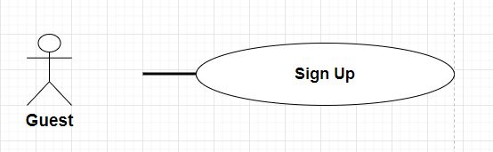

| **UC-02 SIGN UP** | | | |
| --- | --- | --- | --- |
| Use-Case No: | UC - 02 | Use-Case Version: | 1.0 |
| Use-Case Name: | Sign up | Date Created | 14/03/2024 |
| Author: | KietTT | | |
| Actor: | Guest | | |
| Priority: | Medium | Frequency of Use: | Medium |
| Summary: | Guests can create a new account with this system. | | |
| Goal: | This Use-case allows guests to create a new account to login to this system so that he/she can do some specific tasks depending on his/her role. | | |
| Triggers: | There are no triggers for this Use-case | | |
| Pre-conditions: | The user does not have an account with a valid username and password | | |
| Post-conditions: | The user has a valid account to login with the system and he/she is qualified to correspond with his/her role | | |
| Normal Flow: | | Step | Actor Action | System Response | | --- | --- | --- | | 1 | User click “Sign up” button in the navigation bar | System displays a login/register dialog form with the following fields:   * username * password * confirm-password, * fullname * address * gmail * phone contact * Reset , Cancel and Submit Button | | 2 | Guest inputs all following information on the registration form. |  | | 3 | Guest clicks “Submit” button | The system creates a new account for guests with fields provided. | | 4 |  | System generates an activation link for the account | | 5 |  | System sends an email with the activation link to the provided email address. | | 6 |  | System displays a message to notify that an account has been created and an activation email has been sent to the registered email address | | 7 | Guest visits his/her email account and opens the activation email. |  | | 8 | Guest clicks the activation link. | System activates the new account, then deletes the activations link from the database | | 9 |  | System displays a message to notify that the account has been activated. | | 10 |  | System redirect guest to Home Page | | | |
| Alternative Flow: | There is no Alternative Flow | | |
| Exceptions: | | No | Cause | System Response | | --- | --- | --- | | 1 | At least one input field does not match the constraint | System shows an error message corresponding to the fail constraint. | | 2 | User input unavailable phone number | System show error messages “unavailable phone number” | | 3 | User input unavailable email | System show error messages  “Unavailable email” | | 4 | User-provided password does not meet complexity rules | System detects that the provided password does not meet the specified complexity requirements (e.g., minimum length, inclusion of special characters). | | 5 | User encounters technical issues during registration | System displays an error message indicating the technical issue and advises the user to try again later or contact customer support for assistance |   This use case is related to the "Sign In" use case, as users will need to sign in after registering | | |
| Business rules | | No | | | --- | --- | | BR-01,BR-02 | | | | | |

### **UC-03 View News**

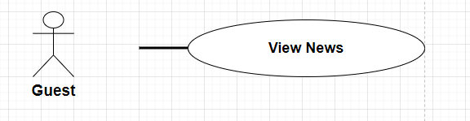

| **UC-03 View News** | | | |
| --- | --- | --- | --- |
| Use-Case No: | UC - 03 | Use-Case Version: | 1.0 |
| Use-Case Name: | View News | Date Created | 14/03/2024 |
| Author: | KietTT | | |
| Actor: | Guest , Customer | | |
| Priority: | High | Frequency of Use: | Medium |
| Summary: | User views news articles related to the construction industry. | | |
| Goal: | This function keeps users informed about relevant industry news and updates. | | |
| Triggers: | User clicks on a "News" section or link on the homepage.  User searches for specific news keywords. | | |
| Pre-conditions: | User has internet access and is on the system's website. | | |
| Post-conditions: | User has viewed relevant news articles. | | |
| Main success Scenario | | Step | Actor Action | System Response | | --- | --- | --- | | 1 | User clicks on the "News" section or link. | The system displays a list of news articles. | | 2 | User (optional) enters keywords in a search bar. | The system filters the news article list based on keywords. | | 3 | User clicks on a specific news article title. | The system displays the full content of the selected news article. | | 4 | User (optional) navigates through news articles using pagination or other controls | The system displays additional news articles based on user selection. | | | |
| Alternative Flow: | * No News Available: If no news articles are available, the system displays a message informing the user. * Search Returns No Results: If the user's search keywords yield no results, the system displays a message informing the user and suggesting alternative keywords. | | |
| Exceptions: | | No | Cause | System Response | | --- | --- | --- | | 1 | Server error | The system will show the ERROR Page . | | | |
| Business rules | | No | | | --- | --- | | BR-05,BR-06,BR-07 | | | | | |

### **UC- 04: Reference Standard Quotation**

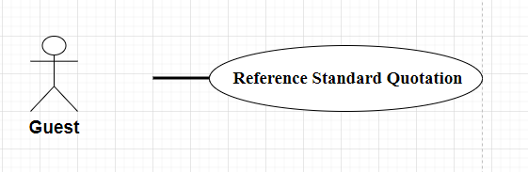

| **UC-04: Reference Standard Quotation** | | | |
| --- | --- | --- | --- |
| Use-Case No: | UC-04 | Use-Case Version: | /1.0 |
| Use-Case Name: | Reference Standard Quotation | Date Created | 18/03/2024 |
| Author: | Gia Phu | | |
| Actor: | Guest | | |
| Priority: | Normal | Frequency of Use: | Normal |
| Summary: | Users can view and consult prices of products, but cannot add to cart. | | |
| Goal: | This use case provides users with prices of available products. | | |
| Triggers: | Users want to see the price of the product. | | |
| Pre-conditions: | The user has accessed the website. | | |
| Post-conditions: | The user can view the price of the product. | | |
| Main success Scenario | | Step | Actor Action | System Response | | --- | --- | --- | | 1 | The user clicks on “Quotation” button in the navigation bar | The system navigates users to the Quotation page and shows the following information: Listed price list, List of products. Estimated price list. | | 2 | The user read content they want |  | | | |
| Alternative Flow: | N/A | | |
| Exceptions: | | No | Cause | System Response | | --- | --- | --- | | 1 | Server error | The system will show the ERROR Page . | | | |
| Business rules | | No | | | --- | --- | | BR-11,BR-12,BR-13,BR-14 | | | | | |

### **UC- 05: View Completed Project List**

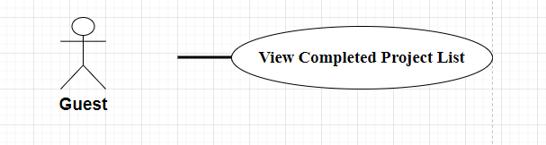

| **UC-05 View Completed Project List** | | | |
| --- | --- | --- | --- |
| Use-Case No: | UC-05 | Use-Case Version: | 1.0 |
| Use-Case Name: | View Completed Project List | Date Created | 18/3/2023 |
| Author: | Gia Phu | | |
| Actor: | Guest | | |
| Priority: | Normal | Frequency of Use: | Normal |
| Summary: | This use case allows users to view the price of a completed project. | | |
| Goal: | This use case provides users with prices of completed projects | | |
| Triggers: | Users want to see prices of completed projects | | |
| Pre-conditions: | Pre-1: The user has accessed the website.  Pre-2: There are projects that have been completed and posted publicly on the website | | |
| Post-conditions: | The user can view prices of completed projects. | | |
| Main success Scenario | | Step | Actor Action | System Response | | --- | --- | --- | | 1 | The user navigates and clicks on “Project” button in the navigation bar | The system navigates users to the Project page and shows the following information: List of complete Project posted under navigation bar , “search” box by Project name. | | 2 | The user can choose to perform other actions on the website |  | | | |
| Alternative Flow: | N/A | | |
| Exceptions: | | No | Cause | System Response | | --- | --- | --- | | 1 | Server error | The system will show the ERROR Page . | | | |
| Business rules | | No | | | --- | --- | | BR-15,BR-16,BR-17 | | | | | |

### **UC- 06 View Completed Project Detail**

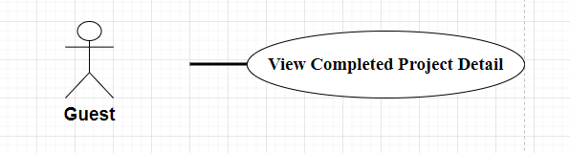

| **UC-06 View Completed Project Detail** | | | |
| --- | --- | --- | --- |
| Use-Case No: | UC-06 | Use-Case Version: | 1.0 |
| Use-Case Name: | View Completed Project Detail | Date Created | 18/3/2024 |
| Author: | Gia Phu | | |
| Actor: | Guest | | |
| Priority: | Normal | Frequency of Use: | Normal |
| Summary: | The User can access and view information of a complete project. | | |
| Goal: | This use case provides users with detail information of completed projects | | |
| Triggers: | User selects a Project to view | | |
| Pre-conditions: | Pre-1: The user has accessed the website or application  Pre-2: The Project is available in the system. | | |
| Post-conditions: | The user can view the selected Project details and content | | |
| Main success Scenario | | Step | Actor Action | System Response | | --- | --- | --- | | 1 | User selects a specific Project from the list. | The system navigates users to Project Details based on Project card , then shows following information :   * Design Project * Location * Client * Architect * Our approach * Related Projects | | 2 | The user can navigate back to the Project list or choose to perform other actions on the website |  | | | |
| Alternative Flow: | N/A | | |
| Exceptions: | | No | Cause | System Response | | --- | --- | --- | | 1 | Server error | The system will show the ERROR Page . | | | |
| Business rules | | No | | | --- | --- | | BR-15,BR-16,BR-17 | | | | | |

### **UC - 07: View Product**

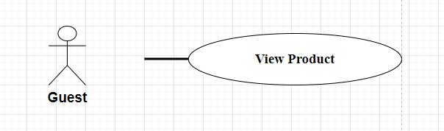

| **UC-07 View Product** | | | |
| --- | --- | --- | --- |
| **Use-Case No:** | UC - 08 | Use-Case Version: | 1.0 |
| **Use-Case Name:** | View Product | Date Created | 18/3/2024 |
| **Author:** | Gia Phu | | |
| **Actor:** | Guest | | |
| **Priority:** | High | Frequency of Use: | High |
| **Summary:** | Give users access to see all the products the website has available, but can not order. | | |
| **Goal:** | This use case provides users with prices of products that available | | |
| **Triggers:** | Users want to see prices of products | | |
| **Pre-conditions:** | Pre-1: Users need to access this website.  Pre-2: The Product is available and published on the website | | |
| **Post-conditions:** | The user can view prices of Products. | | |
| **Main success Scenario** | | Step | Actor Action | System Response | | --- | --- | --- | | 1 | The user navigates and clicks on “Product” button in the navigation bar | The system navigates users to the Project page and shows the following information: List of Products posted under navigation bar , “search” box by Product name. | | 2 | The user can choose to perform other actions on the website |  | | | |
| **Alternative Flow:** | N/A | | |
| **Exceptions:** | | No | Cause | System Response | | --- | --- | --- | | 1 | Server error | The system will show the ERROR Page . | | | |
| Business rules | | No | | | --- | --- | | BR-08,BR-09,BR-10 | | | | | |

### 

### **UC - 08: View Product Detail**

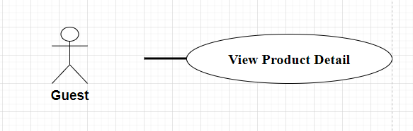

|  | | | |
| --- | --- | --- | --- |
| **Use-Case No:** | UC-08 | Use-Case Version: | 1.0 |
| **Use-Case Name:** | View Product Detail | Date Created | 18/3/2024 |
| **Author:** | Gia Phu | | |
| **Actor:** | Guest | | |
| **Priority:** | Normal | Frequency of Use: | Normal |
| **Summary:** | The User can access and view information of a product. | | |
| **Goal:** | This use case provides users with detail information of completed projects | | |
| **Triggers:** | User selects a Product to view | | |
| **Pre-conditions:** | Pre-1: The user has accessed the website or application  Pre-2: The Products are available in the system. | | |
| **Post-conditions:** | The user can view the selected Product details and content | | |
| **Main success Scenario** | | Step | Actor Action | System Response | | --- | --- | --- | | 1 | User selects a specific Products from the list. | The system navigates users to Product Details based on Product card , then shows following information :   * Product Name * Product Design * Product Size | | 2 | The user can navigate back to the Product list or choose to perform other actions on the website |  | | | |
| Alternative Flow: | N/A | | |
| **Exceptions:** | | No | Cause | System Response | | --- | --- | --- | | 1 | Server error | The system will show the ERROR Page . | | | |
| Business rules | | No | | | --- | --- | | BR-08,BR-09,BR-10 | | | | | |

### 

### **UC - 09: Search Product**

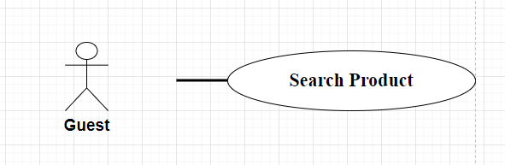

| **UC-09 Search Product** | | | |
| --- | --- | --- | --- |
| **Use-Case No:** | UC-09 | Use-Case Version: | 1.0 |
| **Use-Case Name:** | Search Product | Date Created | 18/3/2024 |
| **Author:** | Gia Phu | | |
| **Actor:** | Guest | | |
| **Priority:** | Normal | Frequency of Use: | Normal |
| **Summary:** | Users can search for a product by name | | |
| **Goal:** | This use case provides users with the functionality to search for products by name | | |
| **Triggers:** | User wants to find a product | | |
| **Pre-conditions:** | Pre-1: The user has accessed the website or application  Pre-2: The Product is available in the system. | | |
| **Post-conditions:** | Users find the product they are looking for | | |
| **Main success Scenario** | | Step | Actor Action | System Response | | --- | --- | --- | | 1 | The user clicks on “Search” button in the navigation bar |  | | 2 | The user enter name product they want to find |  | | 3 | Display search results | The system displays search results according to the product name the user enters | | | |
| Alternative Flow: | N/A | | |
| **Exceptions:** | | No | Cause | System Response | | --- | --- | --- | | 1 | Server error | The system will show the ERROR Page . | | 2 | No products found | The system will show the ERROR message | | 3 | Syntax error or invalid format | The system will show the ERROR message | | | |
| Business rules | | No | | | --- | --- | | BR-08,BR-09,BR-10 | | | | | |

### **UC - 10: View Quotation List**

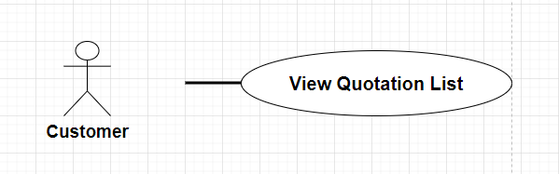

| **UC - 10: View Quotation List** | | | |
| --- | --- | --- | --- |
| **Use-Case No:** | **UC - 10** | Use-Case Version: | 1.0 |
| **Use-Case Name:** | View Quotation List | Date Created | 20/03/2024 |
| **Author:** | KhoiLM | | |
| **Actor:** | Customer | | |
| **Priority:** | High | Frequency of Use: | Medium |
| **Summary:** | User can view quotation list | | |
| **Goal:** | Customer view list of quotation successfully | | |
| **Triggers:** | Customer want to view quotation list | | |
| **Pre-conditions:** | Pre - 1: Customer need to login the system | | |
| **Post-conditions:** | The system show quotation list | | |
| **Main success Scenario** | | Step | Actor Action | System Response | | --- | --- | --- | | 1 | User login system | Home page | | 2 | User click on quotation in navigation | The system displays the list of quotations. | | | |
| Alternative Flow: | N/A | | |
| **Exceptions:** | | No | Cause | System Response | | --- | --- | --- | | 1 | No Quotations Available | Display a message indicating that no quotations are available to view | | 2 | Unauthorised Access | Redirect them to the login page and prompt them to authenticate before proceeding. | | | |
| Business rules | | No | | | --- | --- | | BR-11,BR-12,BR-13,BR-14 | | | | | |

### **UC - 11: Cancel Quotation**

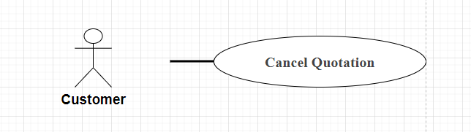

| **UC - 11: Cancel Quotation** | | | |
| --- | --- | --- | --- |
| **Use-Case No:** | **UC - 11** | Use-Case Version: | 1.0 |
| **Use-Case Name:** | Cancel Quotation | Date Created | 20/03/2024 |
| **Author:** | KhoiLM | | |
| **Actor:** | Customer | | |
| **Priority:** | Medium | Frequency of Use: | Medium |
| **Summary:** | The user can cancel a quotation that has been previously created. | | |
| **Goal:** | To allow the customer to cancel a quotation. | | |
| **Triggers:** | The customer decides to cancel a quotation. | | |
| **Pre-conditions:** | Pre-1: The customer must be logged into the system.  Pre-2: The quotation to be cancelled must exist in the system. | | |
| **Post-conditions:** | The quotation is successfully cancelled, and relevant parties are notified. | | |
| **Main success Scenario** | | Step | Actor Action | System Response | | --- | --- | --- | | 1 | Customer logs into the system. | Home page | | 2 | Customer navigates to the list of their quotations. | List Quotation | | 3 | Customer selects the quotation they want to cancel. |  | | 4 | Customer initiates the cancellation process. | The system prompts the customer to confirm the cancellation. | | 5 | Customer confirms the cancellation. | The system updates the status of the quotation to "Cancelled." | | | |
| Alternative Flow: | N/A | | |
| **Exceptions:** | | No | Cause | System Response | | --- | --- | --- | | 1 | The customer attempts to cancel a quotation that does not exist | The system notifies the customer that the selected quotation cannot be found or is not eligible for cancellation. | | 2 | The customer encounters an error while confirming the cancellation. | The system displays an error message indicating that the cancellation confirmation process failed | | | |
| Business rules | | No | | | --- | --- | | BR-11,BR-12,BR-13,BR-14 | | | | | |

### **UC - 12: View Quotation Detail**

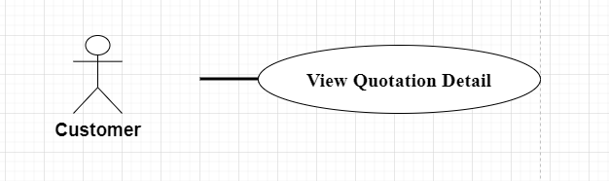

| **UC - 12 View Quotation Details** | | | |
| --- | --- | --- | --- |
| Use-Case No: | UC-12 | Use-Case Version: | /1.0 |
| Use-Case Name: | View Quotation Details | Date Created | 18/03/2024 |
| Author: | KietTT | | |
| Actor: | Customer | | |
| Priority: | Medium | Frequency of Use: | Medium |
| Summary: | The User can access and view information in blog posts.. | | |
| Goal: | This function helps the user to view quotes. | | |
| Triggers: | Customer want to see the price quote of their order | | |
| Pre-conditions: | Users need to log in with a Customer account | | |
| Post-conditions: | The user can view their quote . | | |
| Main success Scenario | | Step | Actor Action | System Response | | --- | --- | --- | | 1 | The user clicks on “Quotation” button in the navigation bar | The system navigates users to the Quotation page and shows the following information: Listed price list, List of products. Estimated price list. | | 2 | The user read and write content they want |  | | | |
| Alternative Flow: | N/A | | |
| Exceptions: | | No | Cause | System Response | | --- | --- | --- | | 1 | Server error | The system will show the ERROR Page . | | 2 | The customer is not logged in | The system will ask the customer to log in. | | | |
| Business rules | | No | | | --- | --- | | BR-11,BR-12,BR-13,BR-14 | | | | | |

### **UC - 13: Receive Contract Based On Submitted Quotation**

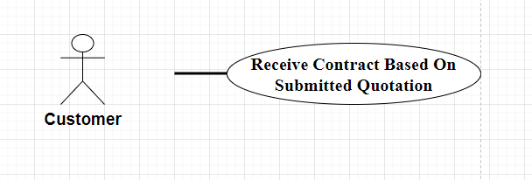

| **UC - 13: Receive Contract Based On Submitted Quotation** | | | |
| --- | --- | --- | --- |
| **Use-Case No:** | UC - 13 | Use-Case Version: | 1.0 |
| **Use-Case Name:** | Receive Contract Based On Submitted Quotation | Date Created | 20/03/2024 |
| **Author:** | KhoiLM | | |
| **Actor:** | Customer | | |
| **Priority:** | Medium | Frequency of Use: | Medium |
| **Summary:** | The customer receives a contract based on the submitted quotation. | | |
| **Goal:** | To formalise the agreement between the customer and the contractor based on the submitted quotation. | | |
| **Triggers:** | The contractor prepares and sends the contract to the customer after reviewing the submitted quotation. | | |
| **Pre-conditions:** | Pre-1: The customer must have submitted a quotation for the interior construction system. | | |
| **Post-conditions:** | The customer receives the contract document. | | |
| **Main success Scenario** | | Step | Actor Action | System Response | | --- | --- | --- | | 1 | The customer submitted the quotation | Confirm message | | 2 | The customer confirmed | Submit success message | | 3 | The contractor sends the contract to the customer. |  | | 4 | The customer receives the contract document. |  | | | |
| Alternative Flow: | N/A | | |
| **Exceptions:** | | No | Cause | System Response | | --- | --- | --- | | 1 | Submitted failed due to network error | Error message | | 2 | Submitted failed due not exist quotation | Error message | | | |
| Business rules | | No | | | --- | --- | | BR-11,BR-12,BR-13,BR-14 | | | | | |

### **UC - 14: View Contract Detail**

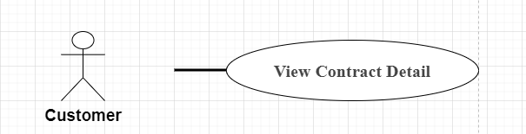

| **UC - 14: View Contract Detail** | | | |
| --- | --- | --- | --- |
| **Use-Case No:** | UC - 14 | Use-Case Version: | 1.0 |
| **Use-Case Name:** | View Contract Detail | Date Created | 20/03/2024 |
| **Author:** | KhoiLM | | |
| **Actor:** | Customer | | |
| **Priority:** | High | Frequency of Use: | Medium |
| **Summary:** | The customer can view the details of a contract. | | |
| **Goal:** | To provide the customer with access to the details of a contract. | | |
| **Triggers:** | The customer wants to review the details of a specific contract. | | |
| **Pre-conditions:** | Pre - 1: Customer must submitted quotation  Pre - 2: Customer receive contract | | |
| **Post-conditions:** |  | | |
| **Main success Scenario** | | Step | Actor Action | System Response | | --- | --- | --- | | 1 | The customer logs into the system. |  | | 2 | The customer navigates to the list of their contracts. | The system retrieves and displays the details of the selected contract, including terms, conditions, and other relevant information. | | | |
| Alternative Flow: | N/A | | |
| **Exceptions:** | | No | Cause | System Response | | --- | --- | --- | | 1 | No contract to view | Error message | | | |
| Business rules | | No | | | --- | --- | | BR-11,BR-12,BR-13,BR-14 | | | | | |

### **UC - 15: Confirm Contract**

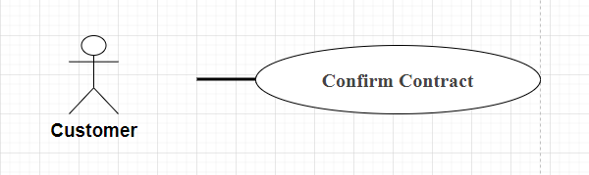

| **UC - 15: Confirm Contract** | | | |
| --- | --- | --- | --- |
| **Use-Case No:** | UC - 15 | Use-Case Version: | 1.0 |
| **Use-Case Name:** | Confỉm contract | Date Created | 20/03/2024 |
| **Author:** | KhoiLM | | |
| **Actor:** | Customer | | |
| **Priority:** |  | Frequency of Use: |  |
| **Summary:** | The customer confirms their acceptance of a contract. | | |
| **Goal:** | To formalise the agreement between the customer and the contractor by confirming the contract. | | |
| **Triggers:** | The customer decides to confirm the contract after reviewing its details. | | |
| **Pre-conditions:** | Pre-1: The customer must have reviewed the contract details. | | |
| **Post-conditions:** | The customer successfully confirm contract | | |
| **Main success Scenario** | | Step | Actor Action | System Response | | --- | --- | --- | | 1 | The customer selects the contract they want to confirm. |  | | 2 | The customer confirms their acceptance of the contract. | The system updates the status of the contract to "Confirmed." | | | |
| Alternative Flow: | N/A | | |
| **Exceptions:** | | No | Cause | System Response | | --- | --- | --- | | 1 | No contract to confirm | Error message | | | |
| Business rules | | No | | | --- | --- | | BR-11,BR-12,BR-13,BR-14 | | | | | |

### **UC - 16: Create Quotation**

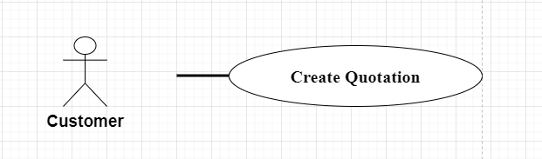

| **UC - 16: Create Quotation** | | | |
| --- | --- | --- | --- |
| **Use-Case No:** | UC - 16 | Use-Case Version: | 1.0 |
| **Use-Case Name:** | Create Quotation | Date Created | 20/03/2024 |
| **Author:** | KhoiLM | | |
| **Actor:** | Customer | | |
| **Priority:** | High | Frequency of Use: | High |
| **Summary:** | The customer creates a new quotation for interior construction services. | | |
| **Goal:** | To provide the customer with the ability to generate a quotation for their interior construction project. | | |
| **Triggers:** | The customer decides to request a quotation for interior construction services. | | |
| **Pre-conditions:** | Pre - 1: Customer need to login the system | | |
| **Post-conditions:** | Create quotation successfully | | |
| **Main success Scenario** | | Step | Actor Action | System Response | | --- | --- | --- | | 1 | Customer login to the system | Homepage | | 2 | The customer navigates to the "Create Quotation" section. |  | | 3 | The customer fills out the required information for the quotation, such as project details, desired services, materials, and any other relevant specifications. |  | | 4 | The customer submits the quotation request. | The system response confirm message | | 5 | Customer confirm message |  | | 6 |  |  | | 7 |  |  | | 8 |  |  | | | |
| Alternative Flow: | N/A | | |
| **Exceptions:** | | No | Cause | System Response | | --- | --- | --- | | 1 | Create fail due network | Error message | | 2 | The customer fill wrong in detail | Error message | | | |
| Business rules | | No | | | --- | --- | | BR-11,BR-12,BR-13,BR-14 | | | | | |

### **UC - 17: Manage Cart**

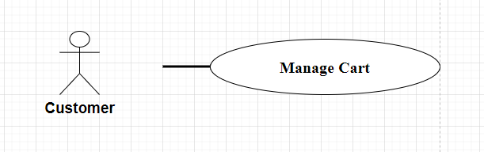

| **UC - 17: Manage Cart** | | | |
| --- | --- | --- | --- |
| **Use-Case No:** | UC - 17 | Use-Case Version: | 1.0 |
| **Use-Case Name:** | Manage Cart | Date Created | 20/03/2024 |
| **Author:** | KhoiLM | | |
| **Actor:** | Customer | | |
| **Priority:** | Medium | Frequency of Use: | Medium |
| **Summary:** | The customer can manage items in their shopping cart. | | |
| **Goal:** | To provide the customer with the ability to add, remove, and update items in their shopping cart. | | |
| **Triggers:** | The customer interacts with their shopping cart to make changes. | | |
| **Pre-conditions:** | Pre - 1: Customer must have product in cart | | |
| **Post-conditions:** | Manage cart success | | |
| **Main success Scenario** | | Step | Actor Action | System Response | | --- | --- | --- | | 1 | The customer logs into the system. |  | | 2 | The customer navigates to their shopping cart. |  | | 3 | The customer can view the list of items currently in their cart. |  | | 4 | The customer can add new items to the cart by specifying quantity and selecting products. |  | | 5 | The customer can remove items from the cart. | The system recalculates the total cost of items in the cart based on any changes made. | | 6 |  |  | | 7 |  |  | | 8 |  |  | | | |
| Alternative Flow: | N/A | | |
| **Exceptions:** | | No | Cause | System Response | | --- | --- | --- | | 1 | The customer tries to add an invalid or unavailable item to the cart | The system notifies the customer that the item cannot be added to the cart and provides a reason for the error. | | 2 | An error during the update of the cart, such as a technical issue or database error. | The system displays an error message indicating the failure to update the cart. | | | |
| Business rules | | No | | | --- | --- | | BR-18,BR-19,BR-20 | | | | | |

### **UC - 18: Add Product To Cart**

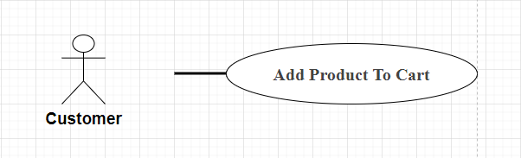

| **UC - 18: Add Product To Cart** | | | |
| --- | --- | --- | --- |
| **Use-Case No:** | UC - 18 | Use-Case Version: | 1.0 |
| **Use-Case Name:** | Add Product to cart | Date Created | 20/03/2024 |
| **Author:** | KhoiLM | | |
| **Actor:** | Customer | | |
| **Priority:** | High | Frequency of Use: | High |
| **Summary:** | The customer adds a product to their shopping cart. | | |
| **Goal:** | To allow the customer to easily add desired products to their shopping cart for purchase. | | |
| **Triggers:** | The customer decides to add a product to their shopping cart. | | |
| **Pre-conditions:** | None | | |
| **Post-conditions:** | Adding successfully | | |
| **Main success Scenario** | | Step | Actor Action | System Response | | --- | --- | --- | | 1 | The customer logs into the system. |  | | 2 | The customer choose product |  | | 3 | The customer clicks on the "Add to Cart" button. | The system adds the selected product to the customer's shopping cart. | | 4 |  |  | | 5 |  |  | | 6 |  |  | | 7 |  |  | | 8 |  |  | | | |
| Alternative Flow: | N/A | | |
| **Exceptions:** | | No | Cause | System Response | | --- | --- | --- | | 1 | The customer tries to add an invalid or unavailable product to their cart. | The system notifies the customer that the selected product cannot be added to the cart and provides a reason for the error. | | 2 | Adding fail due to network | The system show error message | | | |
| Business rules | | No | | | --- | --- | | BR-18,BR-19,BR-20 | | | | | |

### **UC - 19: Change Product's Quantity**

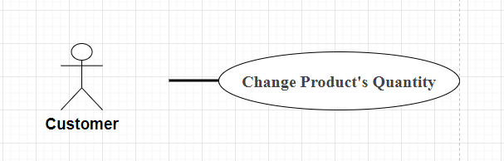

| UC - 19: Change Product’s Quantity | | | |
| --- | --- | --- | --- |
| **Use-Case No:** | UC - 19 | Use-Case Version: | 1.0 |
| **Use-Case Name:** | Change Product’s Quantity | Date Created | 20/03/2024 |
| **Author:** | KhoiLM | | |
| **Actor:** | Customer | | |
| **Priority:** | High | Frequency of Use: | Medium |
| **Summary:** | The customer changes the quantity of a product in their shopping cart. | | |
| **Goal:** | To provide the customer with the ability to adjust the quantity of products in their shopping cart. | | |
| **Triggers:** | The customer decides to modify the quantity of a specific product in their shopping cart. | | |
| **Pre-conditions:** | Pre - 1: Cart have product to manage quantity | | |
| **Post-conditions:** | Successfully change quantity | | |
| **Main success Scenario** | | Step | Actor Action | System Response | | --- | --- | --- | | 1 | The customer goes to cart |  | | 2 | The customer click - on product that exist in cart |  | | 3 | The customer change quantity | System response change success | | | |
| Alternative Flow: | N/A | | |
| **Exceptions:** | | No | Cause | System Response | | --- | --- | --- | | 1 | Change quantity fail due to network connection | Error message | | 2 | Change quantity over limit in system | Error message | | | |
| Business rules | | No | | | --- | --- | | BR-18,BR-19,BR-20 | | | | | |

### **UC - 20: Remove Product From Cart**

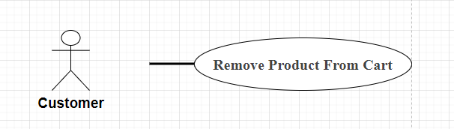

| **UC - 20: Remove Product From Cart** | | | |
| --- | --- | --- | --- |
| **Use-Case No:** | UC - 20 | Use-Case Version: | 1.0 |
| **Use-Case Name:** | Remove ProjectFrom Cart | Date Created | 18/03/2024 |
| **Author:** | KhoiLM | | |
| **Actor:** | Customer | | |
| **Priority:** | Hight | Frequency of Use: |  |
| **Summary:** | This use case describes the process of a customer removing a product from their cart. | | |
| **Goal:** | 1. Allow customers to remove unwanted products from their carts. 2. Update cart information accurately and reflect customer choices. | | |
| **Triggers:** | 1. The customer chooses to remove a product from the cart. 2. The customer changes the number of products in the cart to 0. | | |
| **Pre-conditions:** | 1. The customer is logged into their account or is using a temporary shopping cart. 2. The product to be deleted must be in the shopping cart. | | |
| **Post-conditions:** | 1. The product is removed from the cart. 2. The shopping cart is updated with the latest information. | | |
| **Main success Scenario** | | Step | Actor Action | System Response | | --- | --- | --- | | 1 | The customer selects the product he wants to delete. | The system displays a "Delete" or "Remove from cart" button. | | 2 | The customer clicks the "Delete" button. | The system displays a message confirming the deletion of the product. | | 3 | The customer confirms the deletion of the product. | The system deletes products from the cart and updates cart information. | | | |
| Alternative Flow: | N/A | | |
| **Exceptions:** | N/A | | |
| Business rules | | No | | | --- | --- | | BR-18,BR-19,BR-20 | | | | | |

### **UC - 21: Check Out**

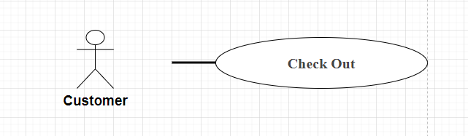

| **UC - 21: Check Out** | | | |
| --- | --- | --- | --- |
| **Use-Case No:** | UC - 21 | Use-Case Version: | 1.0 |
| **Use-Case Name:** | Check out | Date Created | 20/03/2024 |
| **Author:** | KhoiLM | | |
| **Actor:** | Customer | | |
| **Priority:** | High | Frequency of Use: | High |
| **Summary:** | The customer completes the purchase of items in their shopping cart. | | |
| **Goal:** | To allow the customer to finalise their purchase and proceed with payment. | | |
| **Triggers:** | The customer decides to complete the purchase and check out. | | |
| **Pre-conditions:** | Pre - 1: Have product in cart | | |
| **Post-conditions:** | Checkout successfully | | |
| **Main success Scenario** | | Step | Actor Action | System Response | | --- | --- | --- | | 1 | The customer logs into the system. |  | | 2 | The customer navigates to their shopping cart. |  | | 3 | The customer reviews the items in their cart and confirms their selection |  | | 4 | The customer proceeds to the checkout process. |  | | 5 | The system prompts the customer to enter shipping and billing information. |  | | 6 | The system calculates the total cost, including taxes and shipping fees. |  | | 7 | The customer selects a payment method and provides payment details. |  | | 8 |  | The system respond checkout success | | | |
| Alternative Flow: | N/A | | |
| **Exceptions:** | | No | Cause | System Response | | --- | --- | --- | | 1 | Checkout fail due no product in cart | Error message | | 2 | Checkout fail due to network | Error message | | | |
| Business rules | | No | | | --- | --- | | BR-18,BR-19,BR-20 | | | | | |

### **UC - 22: Submit Quotation**

| **UC - 22: Submit Quotation** | | | |
| --- | --- | --- | --- |
| **Use-Case No:** | UC - 22 | Use-Case Version: | 1.0 |
| **Use-Case Name:** | Submit Quotation | Date Created | 20/03/2024 |
| **Author:** | KhoiLM | | |
| **Actor:** | Customer | | |
| **Priority:** | High | Frequency of Use: | High |
| **Summary:** | The customer submits a quotation for interior construction services. | | |
| **Goal:** | To provide the customer with the ability to formally submit their quotation request to the contractor. | | |
| **Triggers:** | The customer decides to proceed with submitting their quotation request. | | |
| **Pre-conditions:** | Pre - 1: The customer have quotation | | |
| **Post-conditions:** | Submitted successfully | | |
| **Main success Scenario** | | Step | Actor Action | System Response | | --- | --- | --- | | 1 | The customer logs into the system. |  | | 2 | The customer navigates to the "Submit Quotation" section. |  | | 3 | The customer fills out the required information for the quotation, such as project details, desired services, materials, and any other relevant specifications. |  | | 4 | The customer submits the quotation request. | The system notifies the contractor about the new quotation request. | | 5 | The customer receives a confirmation message that the quotation request has been successfully submitted. |  | | 6 |  |  | | 7 |  |  | | 8 |  |  | | | |
| Alternative Flow: | N/A | | |
| **Exceptions:** | | No | Cause | System Response | | --- | --- | --- | | 1 | Submitted fail due to network connection | Error message | | | |
| Business rules | | No | | | --- | --- | | BR-11,BR-12,BR-13,BR-14 | | | | | |

### **UC - 23: Select parameters**

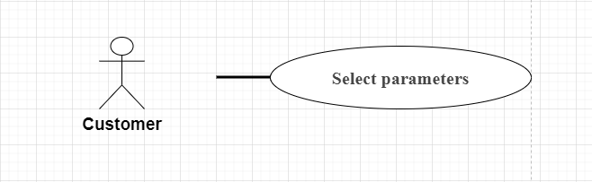

| **UC - 23: Select parameters** | | | |
| --- | --- | --- | --- |
| **Use-Case No:** | UC - 23 | Use-Case Version: | 1.0 |
| **Use-Case Name:** | Select parameters | Date Created | 20/03/2024 |
| **Author:** | KhoiLM | | |
| **Actor:** | Customẻ | | |
| **Priority:** | Medium | Frequency of Use: | Medium |
| **Summary:** | The customer selects parameters for a specific task or process. | | |
| **Goal:** | To provide the customer with the ability to choose parameters according to their requirements. | | |
| **Triggers:** | The customer initiates the process that requires parameter selection. | | |
| **Pre-conditions:** | None | | |
| **Post-conditions:** | None | | |
| **Main success Scenario** | | Step | Actor Action | System Response | | --- | --- | --- | | 1 | The customer initiates the process that requires parameter selection. | The system presents a list of available parameters or options to the customer. | | 2 | The customer selects the desired parameters from the list. | The system confirms the selection made by the customer. | | | |
| Alternative Flow: | N/A | | |
| **Exceptions:** | | No | Cause | System Response | | --- | --- | --- | | | |
| Business rules | | No | | | --- | --- | | BR-11,BR-12,BR-13,BR-14 | | | | | |

### 

### 

### **UC - 24: View profile**

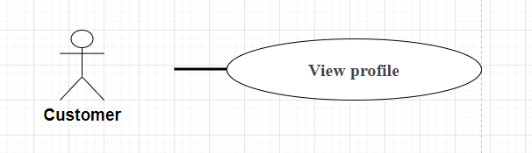

| **UC - 24: View profile** | | | |
| --- | --- | --- | --- |
| **Use-Case No:** | UC-23 | Use-Case Version: | 1.0 |
| **Use-Case Name:** | **View profile** | Date Created | 20/03/2024 |
| **Author:** | KhoiLM | | |
| **Actor:** | Customer | | |
| **Priority:** | High | Frequency of Use: | Frequent |
| **Summary:** | The user views their profile information. | | |
| **Goal:** | This function helps the user to check if their personal information is updated. | | |
| **Triggers:** | The user successfully logs in.  The user clicks on the "Profile" or "Personal Information" link. | | |
| **Pre-conditions:** | The user has registered an account. | | |
| **Post-conditions:** | The user has viewed their profile information. | | |
| **Main success Scenario** | | Step | Actor Action | System Response | | --- | --- | --- | | 1 | The user clicks on the "Profile" or "Personal Information" link. | The system displays the "Profile" page with the user's personal information, including:  - Name  - Email  - Phone number  - Address  - Profile picture | | | |
| Alternative Flow: | * Login Error: If the user is not logged in, the system redirects them to the login page. * Access Error: If the system cannot access the user's profile information, the system displays an error message. | | |
| **Exceptions:** | | No | Cause | System Response | | --- | --- | --- | | 1 | System Error | The system displays an error message and asks the user to try again later. | | 2 |  |  | | 3 |  |  | | 4 |  |  | | | |
| Business rules | | No | | | --- | --- | | BR-03,BR-04 | | | | | |

### **UC - 25: Edit profile**

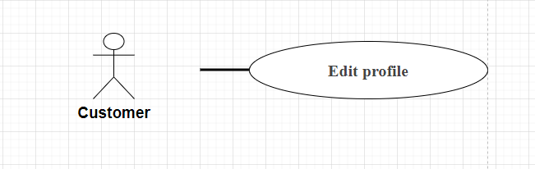

| **UC - 25: Edit profile** | | | |
| --- | --- | --- | --- |
| **Use-Case No:** | UC-25 | Use-Case Version: | 1.0 |
| **Use-Case Name:** | **Edit profile** | Date Created | 20/03/2024 |
| **Author:** | KhoiLM | | |
| **Actor:** | Customer | | |
| **Priority:** | High | Frequency of Use: | Frequent |
| **Summary:** | Users edit their profile information. | | |
| **Goal:** | This function helps users update their personal information. | | |
| **Triggers:** | User logged in successfully.  The user clicks the "Edit profile" or "Update personal information" link. | | |
| **Pre-conditions:** | User has registered an account. | | |
| **Post-conditions:** | The user has edited their profile information. | | |
| **Main success Scenario** | | Step | Actor Action | System Response | | --- | --- | --- | | 1 |  | The system displays the "Edit profile" page with the user's personal information. | | 2 | User edits personal information. | The system checks the validity of the entered information. | | 3 | The user clicks the "Save" button. | The system updates the user's personal information and displays a success message. | | | |
| Alternative Flow: | * Login error: If the user is not logged in, the system will redirect them to the login page. * Access error: If the system cannot access the user's profile information, the system displays an error message. * Validation error: If the information entered is invalid, the system will display an error message and ask the user to re-enter. | | |
| **Exceptions:** | | No | Cause | System Response | | --- | --- | --- | | 1 | System error | The system will display an error message and ask the user to try again later. | | | |
| Business rules | | No | | | --- | --- | | BR-03,BR-04 | | | | | |

### **UC - 26: Manage Account**

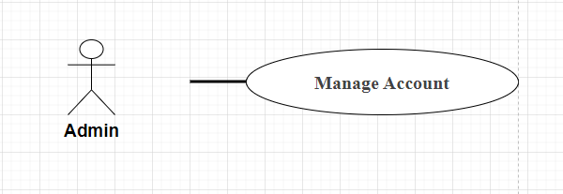

| **UC - 26: Manage Account** | | | |
| --- | --- | --- | --- |
| **Use-Case No:** | UC-26 | Use-Case Version: | /1.0 |
| **Use-Case Name:** | Manage Account | Date Created | 18/03/2024 |
| **Author:** | Lam Khanh | | |
| **Actor:** | Admin | | |
| **Priority:** | Medium | Frequency of Use: | Medium |
| **Summary:** | This use-case describes the actions taken by an admin to manage user accounts within the system. | | |
| **Goal:** | The goal of this use-case is to allow the admin to effectively manage user accounts. | | |
| **Triggers:** | The admin accesses the account management section of the system. | | |
| **Pre-conditions:** | The admin is logged into the system.  The admin has appropriate permissions to manage user accounts. | | |
| **Post-conditions:** | User account changes are successfully implemented within the system. | | |
| **Main success Scenario** | | Step | Actor Action | System Response | | --- | --- | --- | | 1 | Admin accesses account management section | System displays account management interface | | 2 | Admin selects a user account  to manage | System retrieves user account information | | 3 | Admin performs desired System executes requested actions (e.g., edit,  suspend) on the account | System executes requested actions (e.g., edit, delete, delete, suspend) on the selected user account | | 4 | Admin confirms changes made | System updates the user account with the modifications made by the admin | | | |
| Alternative Flow: | N/A | | |
| **Exceptions:** | | No | Cause | System Response | | --- | --- | --- | | 1 | User does not have access | Displays an error message: "Access denied. Access to account management is not available." | | 2 | Error connecting to database | Display error message: "Unable to connect to database. Please try again later." | | | |
| Business rules | | No | | | --- | --- | | BR-03,BR-04 | | | | | |

### **UC - 27: Create Account**

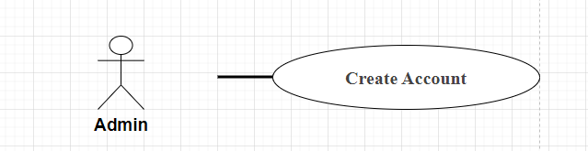

| **UC-27:Create Account** | | | |
| --- | --- | --- | --- |
| **Use-Case No:** | UC-27 | Use-Case Version: | /1.0 |
| **Use-Case Name:** | Create Account | Date Created | 18/03/2024 |
| **Author:** | Lam Khanh | | |
| **Actor:** | Admin | | |
| **Priority:** | Medium | Frequency of Use: | Medium |
| **Summary:** | This use-case outlines the process by which an admin creates a new user account within the system. | | |
| **Goal:** | The goal of this use-case is to enable the admin to successfully create a new user account. | | |
| **Triggers:** | The admin initiates the creation of a new user account. | | |
| **Pre-conditions:** | The admin is logged into the system.  The admin has necessary permissions to create user accounts. | | |
| **Post-conditions:** | A new user account is successfully added to the system. | | |
| **Main success Scenario** | | Step | Actor Action | System Response | | --- | --- | --- | | 1 | Admin accesses account  creation section | System displays account creation interface | | 2 | Admin fills in required information for the new user account | System prompts the admin to enter necessary  information for the new user account (e.g., username,password, email) | | 3 | Admin submits the account creation form | System validates the entered information and creates the new user account in the system | | 4 | System confirms successful account creation | System displays a success message confirming the successful creation of the new user account | | | |
| Alternative Flow: | N/A | | |
| **Exceptions:** | | No | Cause | System Response | | --- | --- | --- | | 1 | Username already exists | The username is already used by another account in the system. | | 2 | The Email was registered | The email address has been used to create another account in the system. | | 3 | Password is too weak | The chosen password is too short or not strong enough. | | 4 | System error | An unexpected error occurred during account creation, such as a connection error. | | | |
| Business rules | | No | | | --- | --- | | BR-03,BR-04 | | | | | |

### **UC - 28: Delete Account**

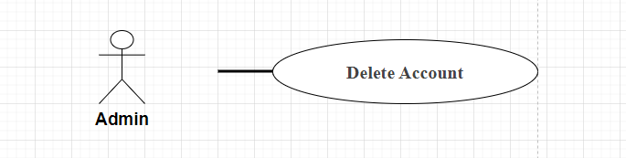

| **UC-28:Delete Account** | | | |
| --- | --- | --- | --- |
| **Use-Case No:** | UC-28 | Use-Case Version: | /1.0 |
| **Use-Case Name:** | Delete Account | Date Created | 18/03/2024 |
| **Author:** | Lam Khanh | | |
| **Actor:** | Admin | | |
| **Priority:** | Medium | Frequency of Use: | Medium |
| **Summary:** | This use-case describes the process by which an admin deletes a user account from the system. | | |
| **Goal:** | The goal of this use-case is to enable the admin to successfully delete a user account. | | |
| **Triggers:** | The admin initiates the deletion of a user account. | | |
| **Pre-conditions:** | The admin is logged into the system.  The admin has appropriate permissions to delete user accounts. | | |
| **Post-conditions:** | The specified user account is permanently removed from the system. | | |
| **Main success Scenario** | | Step | Actor Action | System Response | | --- | --- | --- | | 1 | Admin accesses account management section | System displays account management interface | | 2 | Admin selects the user account to delete | System retrieves user account information | | 3 | Admin initiates the deletion of the account | System prompts the admin to confirm the deletion of the selected user account | | 4 | Admin confirms the deletion | System deletes the user account from the system and displays a success message | | | |
| Alternative Flow: | N/A | | |
| **Exceptions:** | | No | Cause | System Response | | --- | --- | --- | | 1 | Account does not exist | The account the user wants to delete does not exist in the system. | | 2 | Not have access | The user does not have access to delete this account. | | 3 | System error | An unexpected error occurred during the account deletion process, such as a connection error. | | 4 | Account is active | Accounts cannot be deleted while in active status. | | | |
| Business rules | | No | | | --- | --- | | BR-03,BR-04 | | | | | |

### **UC - 29: View Account List**

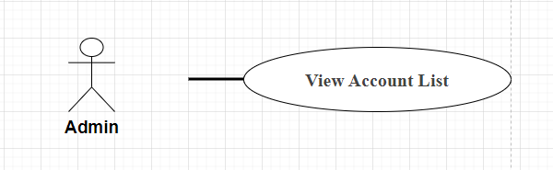

| **UC-29:View Account List** | | | |
| --- | --- | --- | --- |
| **Use-Case No:** | UC-29 | Use-Case Version: | /1.0 |
| **Use-Case Name:** | View Account List | Date Created | 18/03/2024 |
| **Author:** | Lam Khanh | | |
| **Actor:** | Admin | | |
| **Priority:** | Medium | Frequency of Use: | Medium |
| **Summary:** | This use-case outlines the process by which an admin views the list of user accounts in the system. | | |
| **Goal:** | The goal of this use-case is to allow the admin to see the list of all user accounts. | | |
| **Triggers:** | The admin accesses the section to view the list of user accounts. | | |
| **Pre-conditions:** | The admin is logged into the system.  The admin has appropriate permissions to view user accounts. | | |
| **Post-conditions:** |  | | |
| **Main success Scenario** | | Step | Actor Action | System Response | | --- | --- | --- | | 1 | Admin accesses the account list section | System displays the list of user accounts | | 2 | Admin reviews the list of user account email, role, etc. | System presents a paginated list of  user accounts with relevant details such as username, | | 3 | Admin can scroll through or navigate the list | System provides options for the admin to scroll through pages or navigate to specific sections  of the list | | | |
| Alternative Flow: | N/A | | |
| **Exceptions:** | | No | Cause | System Response | | --- | --- | --- | | 1 | Not have access | The user does not have access to view the account list. | | 2 | System error | An unexpected error occurred while retrieving the account list, such as a connection error. | | 3 | Invalid data | The data returned from the account list is invalid or missing necessary information. | | | |
| Business rules | | No | | | --- | --- | | BR-03,BR-04 | | | | | |

### **UC - 30: View Account Detail**

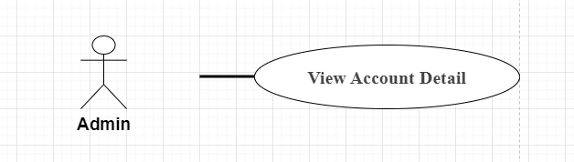

| **UC-30:View Account Detail** | | | |
| --- | --- | --- | --- |
| **Use-Case No:** | UC-30 | Use-Case Version: | /1.0 |
| **Use-Case Name:** | View Account Detail | Date Created | 18/03/2024 |
| **Author:** | Lam Khanh | | |
| **Actor:** | Admin | | |
| **Priority:** | Medium | Frequency of Use: | Medium |
| **Summary:** | This use-case describes the process by which an admin views the detailed information of a specific user account in the system. | | |
| **Goal:** | The goal of this use-case is to enable the admin to access and review detailed information about a particular user account. | | |
| **Triggers:** | The admin selects a specific user account to view its details. | | |
| **Pre-conditions:** | The admin is logged into the system.  The admin has appropriate permissions to view user account details. | | |
| **Post-conditions:** |  | | |
| **Main success Scenario** | | Step | Actor Action | System Response | | --- | --- | --- | | 1 | Admin selects a specific user account to view | System retrieves and displays detailed information about the selected user account | | 2 | Admin reviews the detailed information of the user account | System presents detailed information such as username,email, role, account creation date, last login date, and any other relevant details | | | |
| Alternative Flow: | N/A | | |
| **Exceptions:** | | No | Cause | System Response | | --- | --- | --- | | 1 | Account does not exist | The account that the user wants to view details does not exist in the system. | | 2 | Not have access | The user does not have access to view details for this account. | | 3 | System error | An unexpected error occurred while retrieving account details, such as a connection error. | | | |
| Business rules | | No | | | --- | --- | | BR-03,BR-04 | | | | | |

### **UC -31: Modify Account**

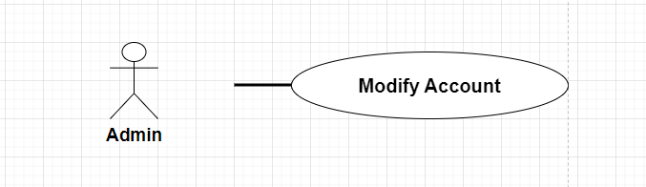

| **UC-31:Modify Account** | | | |
| --- | --- | --- | --- |
| **Use-Case No:** | UC-31 | Use-Case Version: | /1.0 |
| **Use-Case Name:** | Modify Account | Date Created | 18/03/2024 |
| **Author:** | Lam Khanh | | |
| **Actor:** | Admin | | |
| **Priority:** | Medium | Frequency of Use: | Medium |
| **Summary:** | This use-case describes the process by which an admin modifies the details of a user account in the system. | | |
| **Goal:** | The goal of this use-case is to enable the admin to make changes to the details of a user account as required. | | |
| **Triggers:** | The admin initiates the modification of a user account's details. | | |
| **Pre-conditions:** | The admin is logged into the system.  The admin has appropriate permissions to modify user accounts. | | |
| **Post-conditions:** | The changes made to the user account details are successfully updated in the system. | | |
| **Main success Scenario** | | Step | Actor Action | System Response | | --- | --- | --- | | 1 | Admin accesses the account  management section | System displays account management interface | | 2 | Admin selects the user account to modify | System retrieves and displays the current details of the selected user account | | 3 | Admin modifies the details of the user account | System allows the admin to modify the details such as username, email, role, etc. | | 4 | Admin confirms the changes made | System updates the user account with the modifications made by the admin | | | |
| Alternative Flow: | N/A | | |
| **Exceptions:** | | No | Cause | System Response | | --- | --- | --- | | 1 | Invalid data | The data provided for account modification is invalid or lacks necessary information. | | 2 | Authentication error | There was a problem authenticating user information, such as a network error. | | | |
| Business rules | | No | | | --- | --- | | BR-03,BR-04 | | | | | |

### **UC -32: Manage Product**

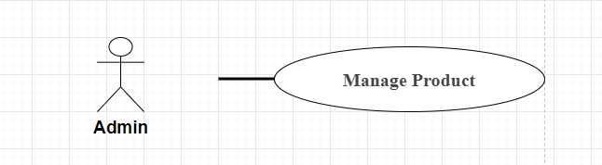

| **UC-32:Manager Product** | | | |
| --- | --- | --- | --- |
| **Use-Case No:** | Uc-32 | Use-Case Version: | /1.0 |
| **Use-Case Name:** | Manage Product | Date Created | 18/03/2024 |
| **Author:** | Lam Khanh | | |
| **Actor:** | Admin | | |
| **Priority:** | Medium | Frequency of Use: | Medium |
| **Summary:** | This use-case describes the actions taken by an admin to manage products within the system. | | |
| **Goal:** | The goal of this use-case is to enable the admin to effectively manage products. | | |
| **Triggers:** | The admin accesses the product management section of the system. | | |
| **Pre-conditions:** | The admin is logged into the system.  The admin has appropriate permissions to manage products. | | |
| **Post-conditions:** | The changes made to the products are successfully updated in the system. | | |
| **Main success Scenario** | | Step | Actor Action | System Response | | --- | --- | --- | | 1 | Admin accesses product management section | System displays product management interface | | 2 | Admin selects a product to manage | System retrieves and displays product details | | 3 | Admin performs desired actions (e.g., edit, delete) on the product | System allows the admin to perform actions such as editing product details, deleting products,adding new products, etc. | | | |
| Alternative Flow: | N/A | | |
| **Exceptions:** | | No | Cause | System Response | | --- | --- | --- | | 1 | Product does not exist | The product that the user wants to manage does not exist in the system. | | 2 | Not have access | The user does not have access to manage this product. | | | |
| Business rules | | No | | | --- | --- | | BR-08,BR-09,BR-10 | | | | | |

### **UC - 33: Add Product**

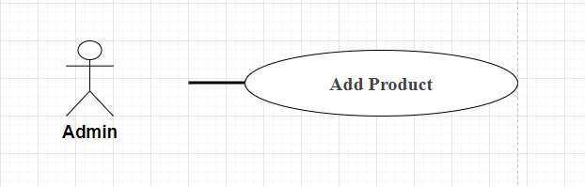

| **UC-33:Add Product** | | | |
| --- | --- | --- | --- |
| **Use-Case No:** | UC-33 | Use-Case Version: | /1.0 |
| **Use-Case Name:** | Add Product | Date Created | 18/03/2024 |
| **Author:** | Lam Khanh | | |
| **Actor:** | Admin | | |
| **Priority:** | Medium | Frequency of Use: | Medium |
| **Summary:** | This use-case describes the process by which an admin adds a new product to the system. | | |
| **Goal:** | The goal of this use-case is to enable the admin to successfully add a new product. | | |
| **Triggers:** | The admin initiates the addition of a new product | | |
| **Pre-conditions:** | The admin is logged into the system.  The admin has appropriate permissions to add products. | | |
| **Post-conditions:** | The new product is successfully added to the system | | |
| **Main success Scenario** | | Step | Actor Action | System Response | | --- | --- | --- | | 1 | Admin accesses product management section | System displays product management interface | | 2 | Admin selects option to add the new product | System presents a form for the admin to fill a new product in details of | | 3 | Admin fills in details of the new product in the system | System validates the entered information and new product creates the in the system | | 4 | Admin submits the new product details | System confirms successful addition of the new product and displays a success message | | | |
| Alternative Flow: | N/A | | |
| **Exceptions:** | | No | Cause | System Response | | --- | --- | --- | | 1 | Product already exists. | The product that the user wants to add already exists in the system | | 2 | No access | The user does not have access to add products. | | | |
| Business rules | | No | | | --- | --- | | BR-08,BR-09,BR-10 | | | | | |

### **UC - 34: Update Product**

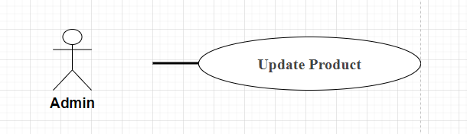

| **UC-34:Update Product** | | | |
| --- | --- | --- | --- |
| **Use-Case No:** | UC-34 | Use-Case Version: | /1.0 |
| **Use-Case Name:** | Update Product | Date Created | 18/03/2024 |
| **Author:** | Lam Khanh | | |
| **Actor:** | Admin | | |
| **Priority:** | Medium | Frequency of Use: | Medium |
| **Summary:** | This use-case describes the process by which an admin updates the details of an existing product in the system. | | |
| **Goal:** | The goal of this use-case is to enable the admin to successfully update the details of a product. | | |
| **Triggers:** | The admin initiates the update of a product. | | |
| **Pre-conditions:** | The admin is logged into the system.  The admin has appropriate permissions to update products. | | |
| **Post-conditions:** | The changes made to the product details are successfully updated in the system. | | |
| **Main success Scenario** | | Step | Actor Action | System Response | | --- | --- | --- | | 1 | Admin accesses product management section | System displays product management interface | | 2 | Admin selects the product to update | System retrieves and displays the current details of the selected product | | | |
| Alternative Flow: | N/A | | |
| **Exceptions:** | | No | Cause | System Response | | --- | --- | --- | | 1 | Product does not exist | The product that the user wants to update does not exist in the system. | | 2 | No access | The user does not have access to update the product. | | 3 | System error | An unexpected error occurred during the product update, such as a connection error. | | | |
| Business rules | | No | | | --- | --- | | BR-08,BR-09,BR-10 | | | | | |

### **UC - 35: Delete Product**

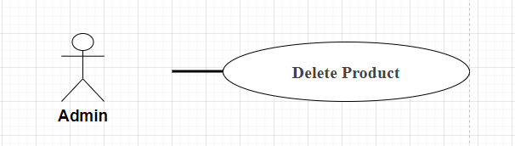

| **UC-35:Delete Product** | | | |
| --- | --- | --- | --- |
| **Use-Case No:** | UC - 35 | Use-Case Version: | /1.0 |
| **Use-Case Name:** | Delete Product | Date Created | 18/03/2024 |
| **Author:** | Lam Khanh | | |
| **Actor:** | Admin | | |
| **Priority:** | Meidum | Frequency of Use: | Medium |
| **Summary:** | Delete the product from the system | | |
| **Goal:** | Efficiently delete products from the system | | |
| **Triggers:** | Request product deletion from Admin | | |
| **Pre-conditions:** | Users must log in to the system as Admin | | |
| **Post-conditions:** | The product has been removed from the system | | |
| **Main success Scenario** | | Step | Actor Action | System Response | | --- | --- | --- | | 1 | Admin selects the product to delete from the product list | Displays product deletion confirmation | | 2 | Admin confirms product deletion | The system deletes products and updates the list | | 3 |  | Display message of successful product deletion | | | |
| Alternative Flow: | N/A | | |
| **Exceptions:** | | No | Cause | System Response | | --- | --- | --- | | 1 | Product does not exist | The product that the user wants to delete does not exist in the system. | | 2 | No access | The user does not have access to delete the product. | | 3 | System error | An unexpected error occurred during product deletion, such as a connection error. | | 4 | Authentication error | A problem occurred during the authentication of user information, such as a network error. | | | |
| Business rules | | No | | | --- | --- | | BR-08,BR-09,BR-10 | | | | | |

### **UC - 36: View Product List**

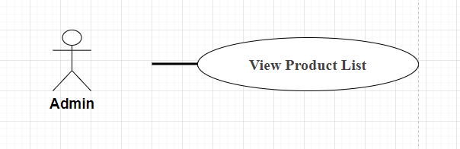

| **UC-36:View Product List** | | | |
| --- | --- | --- | --- |
| **Use-Case No:** | UC-36 | Use-Case Version: | /1.0 |
| **Use-Case Name:** | View Product List | Date Created | 18/03/2024 |
| **Author:** | Lam Khanh | | |
| **Actor:** | Admin | | |
| **Priority:** | Medium | Frequency of Use: | Medium |
| **Summary:** | View the list of products in the system | | |
| **Goal:** | Display product lists visually | | |
| **Triggers:** | Request to see product list from Admin | | |
| **Pre-conditions:** | Users must log in to the system as Admin | | |
| **Post-conditions:** | Display product list | | |
| **Main success Scenario** | | Step | Actor Action | System Response | | --- | --- | --- | | 1 | Admin accesses the product list page | The system displays the product list | | | |
| Alternative Flow: | N/A | | |
| **Exceptions:** | | No | Cause | System Response | | --- | --- | --- | | 1 | Empty Product List Exception | When the product list is empty and there are no products to display. | | 2 | Network Connection Exception | When unable to connect to the server to get product data. | | 3 | Database Connection Exception | When the database cannot be accessed to get the product list. | | | |
| Business rules | | No | | | --- | --- | | BR-08,BR-09,BR-10 | | | | | |

### **UC - 37: View Product Details**

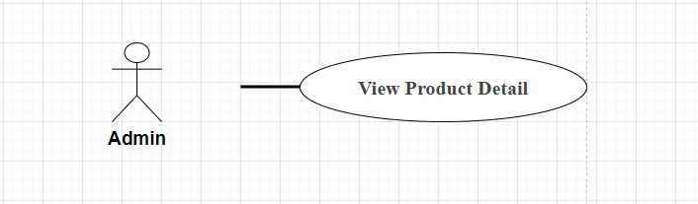

| **UC-37:View Product Detail** | | | |
| --- | --- | --- | --- |
| **Use-Case No:** | UC-37 | Use-Case Version: | /1.0 |
| **Use-Case Name:** | View Product Detail | Date Created | /1.0 |
| **Author:** | Lam Khanh | | |
| **Actor:** | Admin | | |
| **Priority:** | Medium | Frequency of Use: | Medium |
| **Summary:** | View details of a product in the system | | |
| **Goal:** | Display detailed information about the product | | |
| **Triggers:** | Request to see details of a product from Admin | | |
| **Pre-conditions:** | Users must log in to the system as Admin | | |
| **Post-conditions:** | Show details of the product | | |
| **Main success Scenario** | | Step | Actor Action | System Response | | --- | --- | --- | | 1 | Admin selects a product from the product list | The system displays product details | | | |
| Alternative Flow: | N/A | | |
| **Exceptions:** | | No | Cause | System Response | | --- | --- | --- | | 1 | Product Not Found Exception | When the product does not exist in the database or cannot be found. | | 2 | Network Connection Exception | When unable to connect to the server to get detailed product data. | | 3 | Database Connection Exception | When the database cannot be accessed to get detailed product information. | | 4 | Data Retrieval Exception | When product detail data cannot be queried or retrieved from the database. | | | |
| Business rules | | No | | | --- | --- | | BR-08,BR-09,BR-10 | | | | | |

### **UC - 38: View Quotation Request**

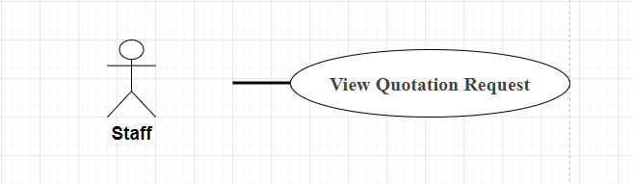

| **UC - 38: View Quotation Request** | | | |
| --- | --- | --- | --- |
| **Use-Case No:** | UC - 38 | Use-Case Version: | 1.0 |
| **Use-Case Name:** | View Quotation Request | Date Created | 18/3/2024 |
| **Author:** | DanhCC | | |
| **Actor:** | Staff | | |
| **Priority:** | Hight | Frequency of Use: |  |
| **Summary:** | Describe the process for viewing employee quote requests | | |
| **Goal:** | Give employees the ability to view quote request details. | | |
| **Triggers:** | When employees receive notification of a new quote request or when they want to review information from an existing quote request | | |
| **Pre-conditions:** | 1. Employees must log in to the system. 2. Quote request must exist in the system. 3. List of products/services 4. Price 5. Delivery time 6. Other terms and conditions | | |
| **Post-conditions:** | Employees can view quote request details, including:   1. Customer information 2. List of products/services 3. Price 4. Other terms and conditions | | |
| **Main success Scenario** | | Step | Actor Action | System Response | | --- | --- | --- | | 1 | Staffs click the link to view the quote request. | The system displays the quote request detail page. | | 2 | Staffs can view the details of the quote request. | The system displays information as required | | 3 | The staff can close the quote request detail page. | The system returns to the quote request list page. | | | |
| Alternative Flow: | N/A | | |
| **Exceptions:** | | No | Cause | System Response | | --- | --- | --- | | 1 | The staff clicks the link to view the quote request, but the link doesn't work. | The system displays the error message "Invalid link". | | 2 | The employee could not find the quote request in the list. | The system displays the message "Quotation request does not exist". | | 3 | The employee tried to edit the quote request, but the system encountered an error. | The system displays the error message "Edit failed". | | | |
| Business rules | | No | | | --- | --- | | BR-11,BR-12,BR-13,BR-14 | | | | | |

### **UC - 39: View Quotation Request Detail**

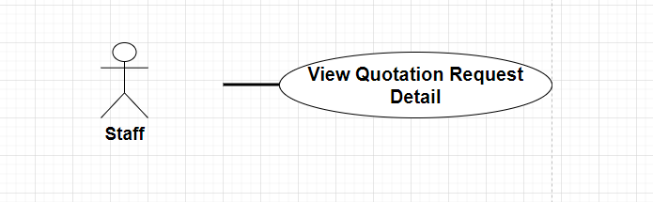

| **UC - 39: View Quotation Request Detail** | | | |
| --- | --- | --- | --- |
| **Use-Case No:** | UC - 39 | Use-Case Version: | 1.0 |
| **Use-Case Name:** | View Quotation Request Detail | Date Created | 18/3/2024 |
| **Author:** | DanhCC | | |
| **Actor:** | Staff | | |
| **Priority:** | Hight | Frequency of Use: |  |
| **Summary:** | This Use Case describes functionality that allows employees to view details of a customer's quote request. | | |
| **Goal:** | Provide employees with detailed information about the quote request so they can process the request effectively. | | |
| **Triggers:** | 1. The employee clicks the "View details" button in the quote request list. 2. Employees receive an email notification of a new quote request. | | |
| **Pre-conditions:** | 1. The employee has logged into the system. 2. Request for quote has been created. | | |
| **Post-conditions:** | 1. Employees can view all information related to the quote request, including:    1. Customer information    2. Product/service information    3. Quantity    4. Specific requirements    5. Expected price    6. Request status 2. Employees can download attached documents (if available). | | |
| **Main success Scenario** | | Step | Actor Action | System Response | | --- | --- | --- | | 1 | The staff clicks the "View details" button in the quote request list. | The system displays the quote request detail page. | | 2 | Employees view detailed information about the quote request. | The system displays all information related to the quote request. | | | |
| Alternative Flow: | N/A | | |
| **Exceptions:** | | No | Cause | System Response | | --- | --- | --- | | 1 | The staff is not logged in | The system displays an error message and requires the employee to log in. | | 2 | Quote request does not exist | The system displays an error message and asks the employee to check again. | | | |
| Business rules | | No | | | --- | --- | | BR-11,BR-12,BR-13,BR-14 | | | | | |

### **UC - 40: Accept Customer's Quotation**

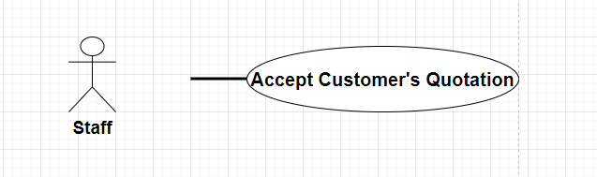

| **UC - 40: Accept Customer’s Quotation** | | | |
| --- | --- | --- | --- |
| **Use-Case No:** | UC - 40 | Use-Case Version: | 1.0 |
| **Use-Case Name:** | Accept Customer's Quotation | Date Created | 18/03/2024 |
| **Author:** | Danh CC | | |
| **Actor:** | Staff | | |
| **Priority:** | High | Frequency of Use: |  |
| **Summary:** | This use case describes the process by which an employee accepts a customer's quote. | | |
| **Goal:** | 1. Accept customer quotes. 2. Create orders for customers. | | |
| **Triggers:** | 1. Customers send quotes. 2. Staffs receive quotes. | | |
| **Pre-conditions:** | 1. The customer has created a quote. 2. Staffs have access to the system. | | |
| **Post-conditions:** | 1. Quotation accepted. 2. Order is created. | | |
| **Main success Scenario** | | Step | Actor Action | System Response | | --- | --- | --- | | 1 | The staff opens the quote. | The system displays quotes. | | 2 | Staff checks quotes. | The system allows employees to check information in quotes. | | 3 | Staff accepts quotes. | The system records the acceptance of the quote. | | 4 | Staff notifies customers. | The staff informs the customer about accepting the quote and creating the order. | | | |
| Alternative Flow: | N/A | | |
| **Exceptions:** | | No | Cause | System Response | | --- | --- | --- | | 1 | The customer requested to amend the quote. | The system allows employees to modify the quote and send the revised quote back to the customer. | | 2 | Customer cancels quote. | The staff notifies the customer about the quote cancellation and records the quote cancellation on the system. | | | |
| Business rules | | No | | | --- | --- | | BR-11,BR-12,BR-13,BR-14 | | | | | |

### **UC - 41: Send Contract To Related Customer**

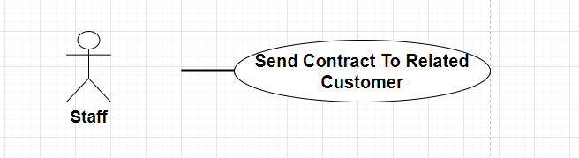

| **UC - 41: Send Contract To Related Customer** | | | |
| --- | --- | --- | --- |
| **Use-Case No:** | UC - 41 | Use-Case Version: | 1 |
| **Use-Case Name:** | Send Contract To Related Customer | Date Created | 18/3/2024 |
| **Author:** | DanhCC | | |
| **Actor:** | Staff | | |
| **Priority:** | Hight | Frequency of Use: |  |
| **Summary:** | This use case describes the process of sending a contract to the relevant customer. | | |
| **Goal:** | The goal of this use case is to send contracts to the relevant customers in an efficient and timely manner. | | |
| **Triggers:** | This use case is triggered when the relevant customer requests a contract. | | |
| **Pre-conditions:** | N/A | | |
| **Post-conditions:** | 1. The customer requests a contract. 2. The contract is sent to the relevant customer. | | |
| **Main success Scenario** | | Step | Actor Action | System Response | | --- | --- | --- | | 1 | Staff creates contract. | The system displays the status to customers | | 2 | The staff enters the email address of the relevant customer. | The system verifies email addresses. | | 3 | The staff clicks the submit button. | The system sends contracts to relevant customers. | | 4 | The relevant customer receives the contract. | The system displays a confirmation message. | | | |
| Alternative Flow: | N/A | | |
| **Exceptions:** | | No | Cause | System Response | | --- | --- | --- | | 1 | Contract not sent | The system displays an error message. | | 2 | No response from the system | The system displays an error message. | | 3 | The concerned customer did not receive the contract | The system displays an error message. | | | |
| Business rules | | No | | | --- | --- | | BR-11,BR-12,BR-13,BR-14 | | | | | |

### **UC - 42: Manage Completed Project**

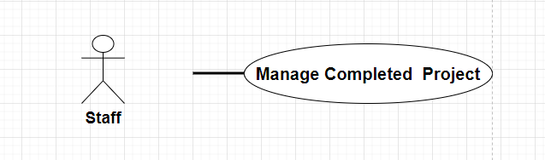

| **UC - 42: Manage Completed Project** | | | |
| --- | --- | --- | --- |
| **Use-Case No:** | UC - 42 | Use-Case Version: | 1 |
| **Use-Case Name:** | Manage Completed Project | Date Created | 18/3/2024 |
| **Author:** | DanhCC | | |
| **Actor:** | Staff | | |
| **Priority:** | Medium | Frequency of Use: |  |
| **Summary:** | This table describes the process of managing a project once it has been completed. | | |
| **Goal:** | 1. Ensure projects are completed and delivered properly. 2. Store project information for future reference. 3. Evaluate the effectiveness of the project and learn from experience for future projects | | |
| **Triggers:** | 1. The project has completed all set goals. 2. Project results report has been approved. | | |
| **Pre-conditions:** | 1. Have a completed project management plan. 2. Full information about the project is available. | | |
| **Post-conditions:** | 1. The project is handed over to the recipient. 2. Project information is stored. 3. Lessons learned. | | |
| **Main success Scenario** | | Step | Actor Action | System Response | | --- | --- | --- | | 1 | Identify and gather feedback from stakeholders | Responses are collected and stored. | | 2 | Store project information | Project information is stored in the repository. | | 3 | Update lessons learned | Lessons learned are updated in the knowledge base. | | | |
| Alternative Flow: | N/A | | |
| **Exceptions:** | | No | Cause | System Response | | --- | --- | --- | | 1 | The project did not complete its intended goals | 1. Determine the reasons why the project did not achieve its goals. 2. Make a plan to overcome the causes. 3. Implement a remediation plan. 4. Evaluate the effectiveness of the remedy. | | 2 | For projects that require changes or additions after completion, the following steps should be taken: | 1. Evaluate the impact of changes or additions. 2. Plan to make changes or additions. 3. Implement plans for changes or additions. 4. Update project information. | | | |
| Business rules | | No | | | --- | --- | | BR-15,BR-16,BR-17 | | | | | |

### **UC - 43: Create New Completed Project**

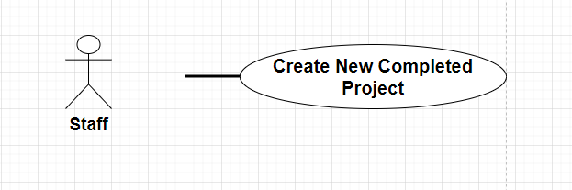

| **UC - 43: Create New Completed Project** | | | |
| --- | --- | --- | --- |
| **Use-Case No:** | UC - 43 | Use-Case Version: | 1 |
| **Use-Case Name:** | Create New Completed Project | Date Created | 18/03/2024 |
| **Author:** | DanhCC | | |
| **Actor:** | Staff | | |
| **Priority:** | Medium | Frequency of Use: |  |
| **Summary:** | Create a new project to record information about a completed project. | | |
| **Goal:** | 1. Store information about completed projects. 2. Allows tracking the progress and effectiveness of projects. | | |
| **Triggers:** | 1. When a project is completed. | | |
| **Pre-conditions:** | 1. The project must be completed. 2. Project information must be readily available. | | |
| **Post-conditions:** | 1. New project created. 2. Project information is stored. | | |
| **Main success Scenario** | | Step | Actor Action | System Response | | --- | --- | --- | | 1 | The employee selects "Create new project". | The system displays the project creation form. | | 2 | Employees enter project information. | Project information storage system. | | 3 | The employee clicks "Save". | The system creates a new project and displays project information. | | | |
| Alternative Flow: | N/A | | |
| **Exceptions:** | | No | Cause | System Response | | --- | --- | --- | | 1 | The staff entered invalid project information. | The system will display an error message and ask the employee to re-enter the information | | 2 | If the system encounters an error when storing project information | The system will display an error message and ask the employee to try again. | | | |
| Business rules | | No | | | --- | --- | | BR-15,BR-16,BR-17 | | | | | |

### **UC - 44: Update Completed Project**

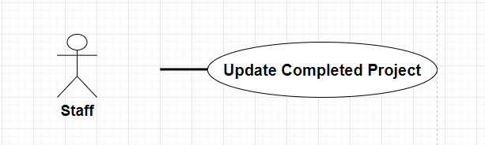

| **UC - 44: Update Completed Project** | | | |
| --- | --- | --- | --- |
| **Use-Case No:** | UC – 44 | Use-Case Version: | 1.0 |
| **Use-Case Name:** | Update Completed Project | Date Created | 18/03/2024 |
| **Author:** | DanhCC | | |
| **Actor:** | Staff | | |
| **Priority:** | Medium | Frequency of Use: |  |
| **Summary:** | This Use Case describes the process for updating information for a completed project. | | |
| **Goal:** | Update accurate and complete information about completed projects, including: Project status, achieved results, lessons learned, related documents | | |
| **Triggers:** | When the project is completed | | |
| **Pre-conditions:** | 1. Project data has been fully collected 2. Employees have access to the system | | |
| **Post-conditions:** | 1. Project information has been successfully updated 2. The system displays a successful update message | | |
| **Main success Scenario** | | Step | Actor Action | System Response | | --- | --- | --- | | 1 | Staffs choose projects that need updating | The system displays detailed project information | | 2 | Staff updates project information | The system checks the validity of the data | | 3 | The system displays an error message if the data is invalid | Staff correct errors and update information | | 4 | The system stores updated information | The system displays a successful update message | | | |
| Alternative Flow: | N/A | | |
| **Exceptions:** | | No | Cause | System Response | | --- | --- | --- | | 1 | Project data is incomplete | Displays an error message and requires full data entry | | 2 | Invalid project data | Display error messages and request corrections | | 3 | The system cannot store updated information | Display an error message and request a retry | | 4 | Staffs do not have access to the system | Display error message and login request | | | |
| Business rules | | No | | | --- | --- | | BR-15,BR-16,BR-17 | | | | | |

### **UC - 45: Delete Completed Project**

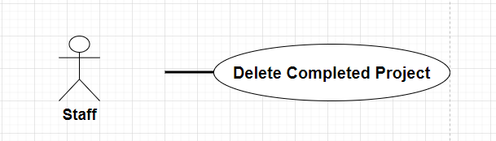

| **UC - 45: Delete Completed Project** | | | |
| --- | --- | --- | --- |
| **Use-Case No:** | UC - 45 | Use-Case Version: | 1.0 |
| **Use-Case Name:** | Delete Completed Project | Date Created | 18/3/2024 |
| **Author:** | DanhCC | | |
| **Actor:** | Staff | | |
| **Priority:** | Medium | Frequency of Use: |  |
| **Summary:** | This use case describes the process of deleting a completed project from the system. | | |
| **Goal:** | Delete completed projects from the system to free up storage space and improve management efficiency. | | |
| **Triggers:** | When the project is marked as complete. | | |
| **Pre-conditions:** | 1. The project must be marked as complete. 2. The employee must have permission to delete projects. | | |
| **Post-conditions:** | 1. The project is deleted from the system. 2. The system log records information about project deletions. | | |
| **Main success Scenario** | | Step | Actor Action | System Response | | --- | --- | --- | | 1 | Select completed project | The system displays a confirmation message | | 2 | Confirm project deletion | The system deletes the project from the system and records it in the log | | | |
| Alternative Flow: | N/A | | |
| **Exceptions:** | N/A | | |
| Business rules | | No | | | --- | --- | | BR-15,BR-16,BR-17 | | | | | |

### **UC - 46: Manage News**

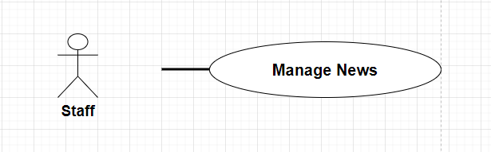

| **UC - 46: Manage News** | | | |
| --- | --- | --- | --- |
| **Use-Case No:** | UC - 46 | Use-Case Version: | 1.0 |
| **Use-Case Name:** | Manage News | Date Created | 18/3/2024 |
| **Author:** | DanhCC | | |
| **Actor:** | Staff | | |
| **Priority:** | Medium | Frequency of Use: |  |
| **Summary:** | This use case describes the steps employees take to manage news on the system. | | |
| **Goal:** | Provide employees with an efficient process for managing news, including: Add new news, Update existing news, Delete news | | |
| **Triggers:** | 1. Staff creates new news 2. Staff updates current news 3. Staff deletes news | | |
| **Pre-conditions:** | 1. Employees must log in to the system 2. Employees must have access to the news management function | | |
| **Post-conditions:** | 1. New news added to the system 2. Current news is updated 3. News is deleted from the system | | |
| **Main success Scenario** | | Step | Actor Action | System Response | | --- | --- | --- | | 1 | The employee clicks the "Add news" button | The system displays the add news form | | 2 | Staff enter titles, content and images for news | The system saves new news | | 3 | The employee clicks the "Update" button | The system displays the news update form | | 4 | Staff updates headlines, content, or images for news stories | The system saves the changes | | 5 | The employee clicks the "Delete" button | The system confirms the deletion of the news | | 6 | The employee clicks the "Confirm" button | The system deletes news | | | |
| Alternative Flow: | N/A | | |
| **Exceptions:** | | No | Cause | System Response | | --- | --- | --- | | 1 | The system does not display the add news form | Employees report errors to the IT department | | 2 | The system does not save new news | The staff checks the entered information and tries again | | 3 | The system does not display the news update form | Employees report errors to the IT department | | 4 | The system does not save changes to news | The staff checks the entered information and tries again | | 5 | The system does not display a notification confirming the deletion of news | Employees report errors to the IT department | | | |
| Business rules | | No | | | --- | --- | | BR-05,BR-06,BR-07 | | | | | |

### **UC - 47: Create News**

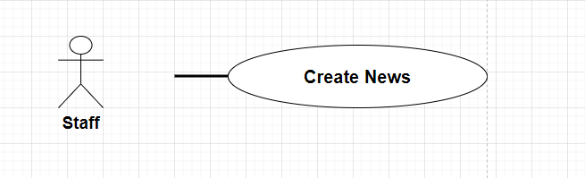

| **UC - 47: Create News** | | | |
| --- | --- | --- | --- |
| **Use-Case No:** | UC - 47 | Use-Case Version: | 1.0 |
| **Use-Case Name:** | Create News | Date Created | 18/03/2024 |
| **Author:** | DanhCC | | |
| **Actor:** | Staff | | |
| **Priority:** | Medium | Frequency of Use: |  |
| **Summary:** | This procedure describes the steps to create news in the system | | |
| **Goal:** | 1. Create accurate and timely news. 2. Meet readers' needs. | | |
| **Triggers:** | 1. A new event happened. 2. There is a need to update information. | | |
| **Pre-conditions:** | 1. Have reliable sources of information. 2. Have a content management system. | | |
| **Post-conditions:** | 1. News is created and published. 2. Readers can access news. | | |
| **Main success Scenario** | | Step | Actor Action | System Response | | --- | --- | --- | | 1 | Identify events | The system displays a list of potential events. | | 2 | Select event | The system displays detailed information about the event. | | 3 | Write articles | The system provides tools for writing articles. | | 4 | Edit article | The system allows editing articles before publishing. | | 5 | Publish articles | The system publishes articles on the website. | | | |
| Alternative Flow: | N/A | | |
| **Exceptions:** | | No | Cause | System Response | | --- | --- | --- | | 1 | The system cannot publish the article | The system displays an error message. | | | |
| Business rules | | No | | | --- | --- | | BR-05,BR-06,BR-07 | | | | | |

### **UC - 48: Update News**

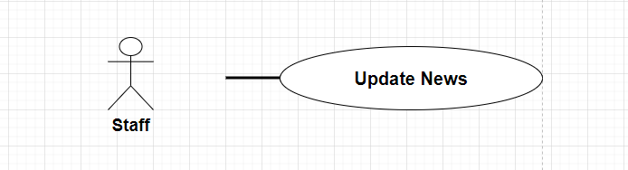

| **UC - 48: Update News** | | | |
| --- | --- | --- | --- |
| **Use-Case No:** | UC - 48 | Use-Case Version: | 1.0 |
| **Use-Case Name:** | Update News | Date Created | 18/03/2024 |
| **Author:** | DanhCC | | |
| **Actor:** | Staff | | |
| **Priority:** | Medium | Frequency of Use: |  |
| **Summary:** | This use case describes how employees can update news on the system. | | |
| **Goal:** | Provide employees with the ability to update content, images, and information related to posted news. | | |
| **Triggers:** | 1. The employee clicks the "Update" button in the news details page. 2. The system receives an update request from the employee's device. | | |
| **Pre-conditions:** | 1. The employee has logged into the system. 2. Employees have access to the news update function. 3. The news that needs to be updated has been selected. | | |
| **Post-conditions:** | 1. News was successfully updated with new content. 2. The system displays a successful update message. | | |
| **Main success Scenario** | | Step | Actor Action | System Response | | --- | --- | --- | | 1 | The staffs clicks the "Update" button | The system displays the news editing page | | 2 | Edit content, images, news information | The system stores changes | | 3 | Click the "Save" button | The system updates news and displays a notification of success | | | |
| Alternative Flow: | N/A | | |
| **Exceptions:** | | No | Cause | System Response | | --- | --- | --- | | 1 |  |  | | 2 |  |  | | 3 |  |  | | 4 |  |  | | | |
| Business rules | | No | | | --- | --- | | BR-05,BR-06,BR-07 | | | | | |

### **UC - 49: Delete News**

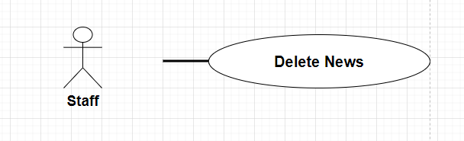

| **UC - 49: Delete News** | | | |
| --- | --- | --- | --- |
| **Use-Case No:** | **UC - 49** | Use-Case Version: | 1.0 |
| **Use-Case Name:** | Delete News | Date Created | 18/03/2024 |
| **Author:** | DanhCC | | |
| **Actor:** | Staff | | |
| **Priority:** | Height | Frequency of Use: |  |
| **Summary:** | This use case describes the process of removing news from a website. | | |
| **Goal:** | 1. Delete news that is no longer relevant or necessary. 2. Update website content. | | |
| **Triggers:** | 1. Staff receive requests to delete news from editors or users. 2. An employee finds a story that needs to be removed due to an error or policy violation. | | |
| **Pre-conditions:** | 1. Employees must log in to the website administration system. 2. Employees must have the right to delete information. 3. The information to be deleted must be identified. | | |
| **Post-conditions:** | 1. News is removed from the website. 2. The system records the news deletion log. | | |
| **Main success Scenario** | | Step | Actor Action | System Response | | --- | --- | --- | | 1 | The staff selects the information to delete. | The system displays a confirmation message. | | 2 | Staff confirmed deletion of news. | The system deletes news from the website and records it in a log. | | | |
| Alternative Flow: | N/A | | |
| **Exceptions:** | N/A | | |
| Business rules | | No | | | --- | --- | | BR-05,BR-06,BR-07 | | | | | |

### **UC - 50: Manage Standard Quotation**

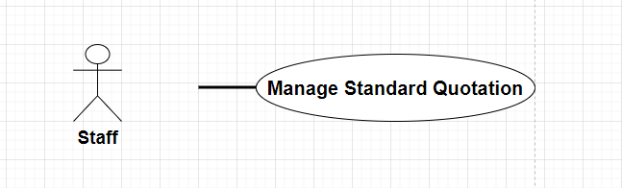

| **UC - 50: Manage Standard Quotation** | | | |
| --- | --- | --- | --- |
| **Use-Case No:** | UC-50 | Use-Case Version: | 1.0 |
| **Use-Case Name:** | Manage Standard Quotation | Date Created | 18/3/2024 |
| **Author:** | Danh CC | | |
| **Actor:** | Staff | | |
| **Priority:** | Normal | Frequency of Use: | Normal |
| **Summary:** | This use case describes the process by which Staff manage customer quotes | | |
| **Goal:** | This use case provides Staff with the ability to manage user quotes | | |
| **Triggers:** | Staff wants to manage user quotes | | |
| **Pre-conditions:** | Pre-1: The Staff has accessed the website or application  Pre-2: The Staff login in with Staff Account | | |
| **Post-conditions:** | Staff can access the Quotations Page | | |
| **Main success Scenario** | | Step | Actor Action | System Response | | --- | --- | --- | | 1 | Staff click “Login” button in the navigation bar | The system will display a form screen with the following fields:   * Username (Staff) * Password (Staff) * [ Login ] Button * [ Reset ] Button to delete all user input * [ Remember Me ] Button to save the cookie of user login . | | 2 | Staff input valid username and password , then clicks on the Login button or hits Enter | The system checks the existing account in the database and takes user to the page for Staff | | 3 |  | The system saves the login session to the log file/database and displays the Staff screen. | | | |
| Alternative Flow: | N/A | | |
| **Exceptions:** | | No | Cause | System Response | | --- | --- | --- | | 1 | Server error | The system will show the ERROR Page . | | | |
| Business rules | | No | | | --- | --- | | BR-11,BR-12,BR-13,BR-14 | | | | | |

### **UC - 51: Create Standard Quotation**

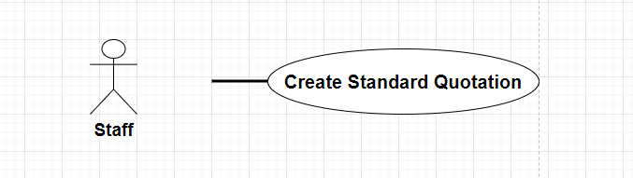

|  | | | |
| --- | --- | --- | --- |
| **Use-Case No:** | UC - 51 | Use-Case Version: | /1.0 |
| **Use-Case Name:** | Create Standard Quotation | Date Created | 18/03/2024 |
| **Author:** | DanhCC | | |
| **Actor:** | Staff | | |
| **Priority:** | Normal | Frequency of Use: | Normal |
| **Summary:** | This use case describes the process by which Staff Create quotes | | |
| **Goal:** | A quote is generated by Staff | | |
| **Triggers:** | Staff want to create new quotes | | |
| **Pre-conditions:** | Pre-1: The Staff has accessed the website or application  Pre-2: The Staff login in with Staff Account | | |
| **Post-conditions:** | Staff can create new quote | | |
| **Main success Scenario** | | Step | Actor Action | System Response | | --- | --- | --- | | 1 | Staff click “Create Quote” button in the navigation bar | The system will display a form screen with the following fields:   * Full name * Phone number * Status * Style | | 2 | Staff enter all fields, the clicks on “Create” button | The system will display a notification of successful creation. | | | |
| **Exceptions:** | | No | Cause | System Response | | --- | --- | --- | | 1 | Server error | The system will show the ERROR Page . | | 2 | The Staff entered the wrong format for the data field. | The system will show the ERROR message | | | |
| Business rules | | No | | | --- | --- | | BR-05,BR-06,BR-07 | | | | | |

### **UC - 52: Update Standard Quotation**

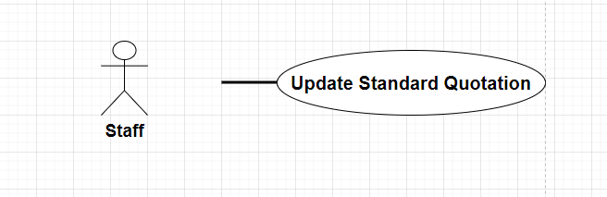

| **UC-52 Update Standard Quotation** | | | |
| --- | --- | --- | --- |
| **Use-Case No:** | UC-52 | Use-Case Version: | 1.0 |
| **Use-Case Name:** | Update Standard Quotation | Date Created | 18/3/2024 |
| **Author:** | DanhCC | | |
| **Actor:** | Staff | | |
| **Priority:** | Normal | Frequency of Use: | Normal |
| **Summary:** | This use case describes the process by which Staff Update quote | | |
| **Goal:** | A quote is updated by Staff | | |
| **Triggers:** | Staff want to update a quote | | |
| **Pre-conditions:** | Pre-1: The Staff has accessed the website or application  Pre-2: The Staff login in with Staff Account | | |
| **Post-conditions:** | Staff can update quote | | |
| **Main success Scenario** | | Step | Actor Action | System Response | | --- | --- | --- | | 1 | The employee clicks the “Update Quote” (pen icon) button in the Action column on the list of Quotations | The system will display a update form screen with the following fields:   * Full name * Phone number * Status * Style | | 2 | Staff enter all fields, the clicks on “Update” button | The system will display a notification of successful updated. | | | |
| **Exceptions:** | | No | Cause | System Response | | --- | --- | --- | | 1 | Server error | The system will show the ERROR Page . | | 2 | The Staff entered the wrong format for the data field. | The system will show the ERROR message | | | |
| Business rules | | No | | | --- | --- | | BR-05,BR-06,BR-07 | | | | | |

### **UC - 53: Delete Standard Quotation**

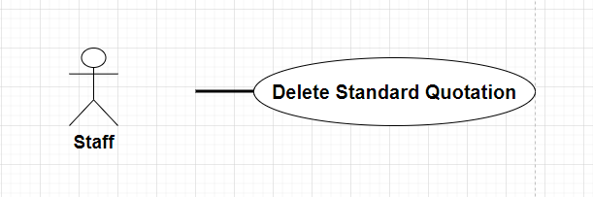

| **UC-53: Delete Standard Quotation** | | | |
| --- | --- | --- | --- |
| **Use-Case No:** | UC-53 | Use-Case Version: | 1.0 |
| **Use-Case Name:** | Delete Standard Quotation | Date Created | 18/03/2024 |
| **Author:** | DanhCC | | |
| **Actor:** | Staff | | |
| **Priority:** | Normal | Frequency of Use: | Normal |
| **Summary:** | This use case describes the process by which Staff Delete quote | | |
| **Goal:** | A quote is deleted by Staff | | |
| **Triggers:** | Staff want to delete a quote | | |
| **Pre-conditions:** | Pre-1: The Staff has accessed the website or application  Pre-2: The Staff login in with Staff Account | | |
| **Post-conditions:** | Staff can delete quote | | |
| **Main success Scenario** | | Step | Actor Action | System Response | | --- | --- | --- | | 1 | The employee clicks the “Delete Quote” (trash can icon) button in the Action column on the list of Quotations | The system displays a notice board "Do you want to delete this quotation?" | | 2 | Staff clicks the Delete button | The system displays a notice board "Delete Quotation successfully" | | | |
| **Exceptions:** | | No | Cause | System Response | | --- | --- | --- | | 1 | Server error | The system will show the ERROR Page . | | | |
| Business rules | | No | | | --- | --- | | BR-05,BR-06,BR-07 | | | | | |

**3.5 ERD**

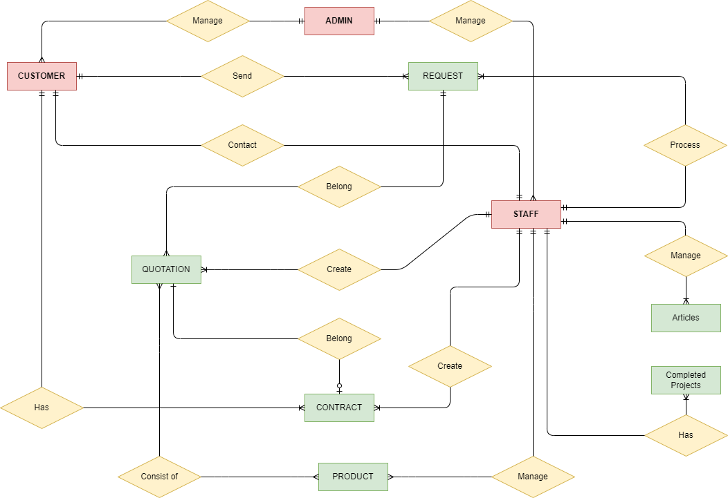

**3.6 Database Design**

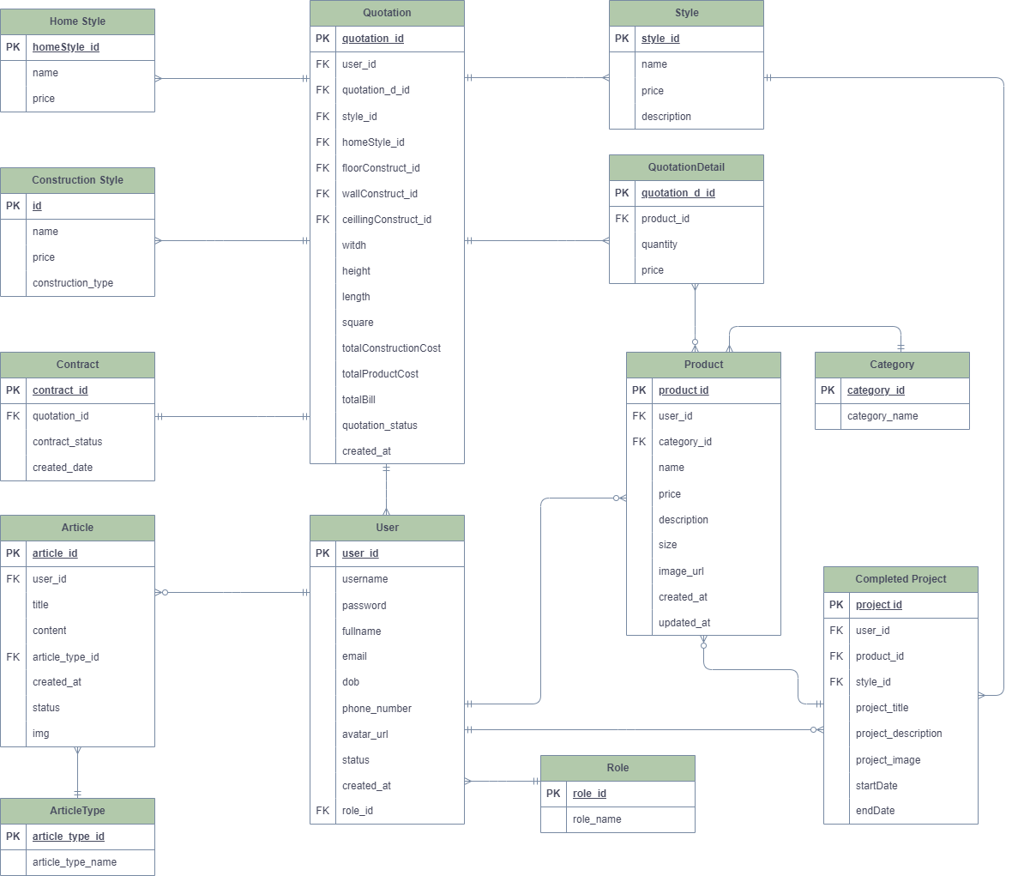

# **4. NON - FUNCTIONAL REQUIREMENTS**

## **4.1. Usability**

* **Learnability**: Users should be able to complete main actions within 30 minutes of initial interaction with the Interior Construction Quotation System.
* **Efficiency**: Users should achieve their quotation goals, such as creating and tracking quotations, within a maximum of 4 steps or interactions.
* **Memorability**: Contractors should be able to return to the system after a period of inactivity, such as a week, and efficiently resume their quotation activities without needing to relearn or consult extensive documentation.
* **Errors**: The system should maintain an error rate of less than 2 percent for commonly performed tasks, such as creating quotations or tracking project progress.
* All text and messages must be written in English.
* The system should feature a user-friendly interface that allows users to understand 90 percent of all functions within 45 minutes.
* The error rate of users submitting payments at the checkout page must not exceed 10 percent.
* The website interface should adhere to the design specified in the figma prototype.

## **4.2. Reliability**

* The Interior Construction Quotation System should maintain a system uptime of at least 97% over a 30-day period, excluding maintenance windows.
* Mean Time Between Failures (MTBF) should exceed 200 hours.
* Mean Time To Repair (MTTR) should be less than 12 hours.
* Response time for a transaction must be 5 seconds or less.
* The system should ensure the integrity of stored data, preventing data corruption or loss.

## **4.3. Performance**

* The response time for requests must be 5 seconds or less.
* The website should support 1,000 users per hour with a response time of 7 seconds or less in a Chrome desktop browser.
* The system should handle a growing number of users and quotations while maintaining optimal performance.

# **5. SOFTWARE TESTING DOCUMENT**

## **5.1.** **Overall Description**

**5.1.1 Test Model**

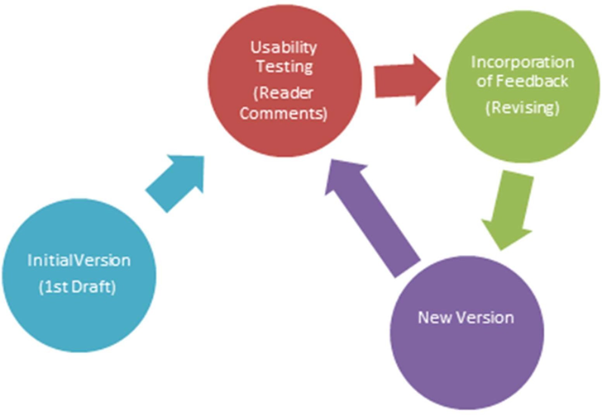

In the planning stage, we decided to use the Iterative Model for testing our system. This model process provides flexibility for a short development time application but still helps to manage and test easily. Moreover, we could also identify the issue earlier and working on it to make a quality deliverable.

The testing process will be started after a new feature is finished on the testing server, this feature will be tested by users and tester (Usability Testing). We will re–check the feature and release a new version for it and return to the Usability Testing step.

**5.1.2 Testing Types**

**a. Function testing**

Perform individually testing to verify the functionalities of major features under specific conditions.

The detailed descriptions of each test case will be described in Report5_Test Case Document.xlsx

**b. User interface testing**

Perform testing on UI controls to verify if they work properly according to their desired functionalities.

Further descriptions of each test case will be described in Report5_Test Case Document.xlsx

**c. API testing**

Perform testing for RESTful APIs implemented for web applications.

Perform testing on Swagger using methods: GET, POST, PUT, DELETE to check responses from the server.

## **5.2.** **Test Plan**

### **5.2.1 Test Stages**

| Type of Test | Stage of Test |
| --- | --- |
| Function Testing | System |
| User Interface Testing | System |
| API Testing | System |

### **5.2.2 Resources**

#### **5.2.2.1 Human Resources**

| Woker/Doer | Role | Specific Responsibilities/Comment |
| --- | --- | --- |
| KietTT | Member | Create Test Report  Manage Test Report  Execute Tests |
| DanhCC | Leader | Assign Test Task  Execute Tests  Review Test Case |
| KhoiLM | Member | Execute Tests  Review Test Case |
| Gia Phu | Member | Execute Tests  Review Test Case |
| Lam Khanh | Member | Execute Tests  Review Test Case |

#### **5.2.2.2 Environment**

| Purpose | Tool | Provider |
| --- | --- | --- |
| View logs of web application | Chorm DevTools | Chorm |
| Test case management | Microsoft Excel | Microsoft |
| Manage API list and manual API testing | SWAGGER | SWAGGER |
| Backend IDE | Visual Studio Code | Microsoft |
| Web application IDE | Visual Studio Code | Visual Studio Code |
| Execution hardware | Testing is implemented on computers with the following specifications:   * CPU: Intel i5/i7 * RAM: ≥4GB * Storage device: HDD or SSD | Any Prodivers |
| Communication | Offline Meeting  Online Meeting Messenger | Discord Google Meet Facebook |

### **5.2.3 Test Cases**

The detailed test case document will be described at this link: [TestReportTemp.xlsx](https://docs.google.com/spreadsheets/d/1SNe2lEajdhGI74CQB5kBzRtGgqmv23NVW71vfFzLolA/edit#gid=462081462)

### **5.2.4 Test Report**

